SMART SCHOOL MIS (MANAGEMENT INFORMATION SYSTEM) SOFTWARE

Smart School is a Cloud based Management Information System (MIS) which focuses on the management of information to provide efficiency and effectiveness of strategic decision making in educational organizations. Smart School MIS can help our college to identify our strengths and weaknesses due to the presence of various reports, employee's and student's performance records. Identifying these aspects can help our organization to improve our academic work processes and operations. MIS gives an overall picture of our college organization. Acts as a communication and planning tool. MIS reports can help to take decision and action on certain object with quick time. The availability of student's and employee's data and their feedback can help the college organization to align its academic work processes according to the needs. The effective management of student's data can help the institute to perform effective decision making and promotion activities. MIS can help to our organization to gain a competitive advantage. Competitive advantage is a institute’s ability to do something better, faster, cheaper, or uniquely, when compared with rival institutes in the education system.

**THE AIM OF SMART SCHOOL SOFTWARE:**

The smart school software is an integration between technology and education,aiming to improve quality of education and increase the effectiveness of the learning process and providing a variety of educational services for students and faculty, such as virtual classroom and electronic communication between students, teachers.

**KEY FEATURES :**

Smart School MIS houses an adept report generation utility that lets you look at all your data from both large and fine combed perspectives, owing to the inbuilt generation of various reports, employee's and student's performance records.

**Analytical Reports**

Gives an exact idea about health of the organization on finger tip. Generates analytical reports for decision making. Live dashboards gives live information of each process.

**Accurate Records**

Create accurate records of each section. Provides complete transparency in data flow process. Useful for all sections like admissions, academics, placements, public relations.

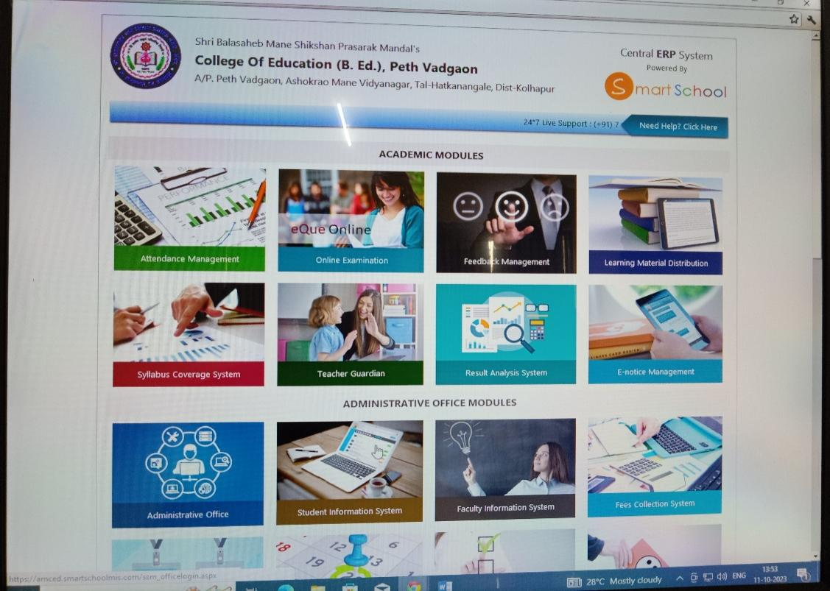

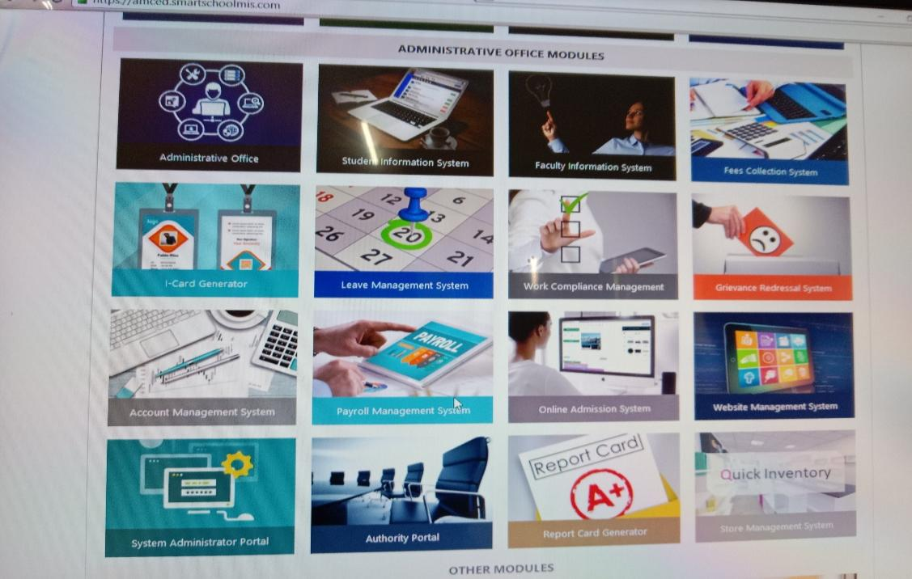

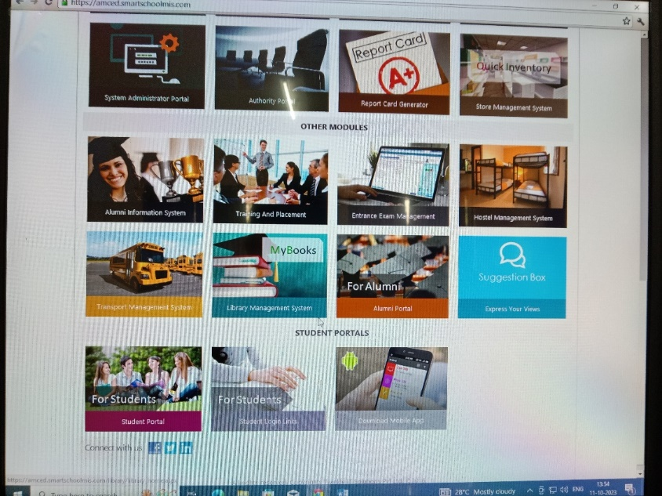

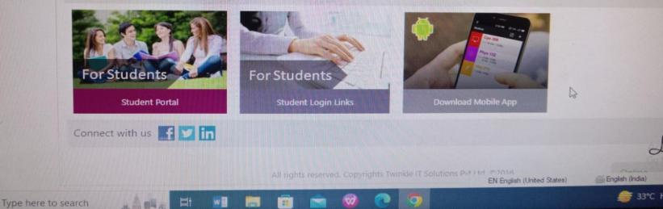

In Smart School MIS Software there are four main modules. Academic module, Administrative office Module, Other module, Student Portal, Download App. Details are as follows:

**Modules of Smart School MIS**

|  |  |  |
| --- | --- | --- |
| Attendance Management | Training and Placement | Mobile App for Faculties |
| Feedback Management | Result Analysis System | Mobile App for Students |
| Online Examination System | Library Management | Mobile App for Authority |
| E-Notice System | Syllabus Coverage | Mobile App for Principal |
| Learning Material System | Teacher Guardian System | System Mobile App for President |
| Alumni Information System | Student Information System | Faculty Information System |
| Transport Management | Grievance Redressal System | Institute Website |
| Portals | | |
| Student Portal | Alumni Portal | Authority Portal |

1. **ACADEMIC MODULE**

**1.1 ATTENDEANCE MANAGEMENT PORTAL**

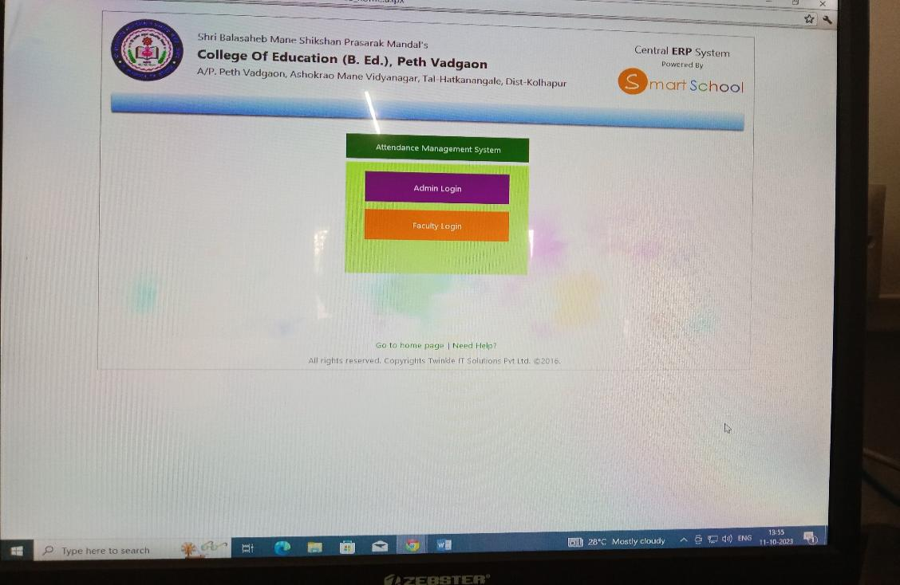

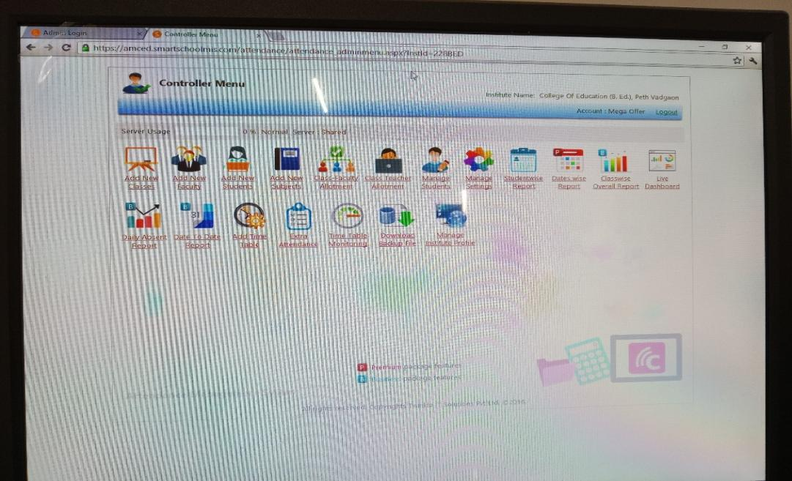

**Academic Management portal features are as follows:**

1. Add new classes 2. Add new faculty 3. Add new students 4. Add new Subject 5. Class-Faculty Allotment 6. Class Teacher Allotment 7. Manage Students 8. Student wise Report 9. Date wise Report 10. Class wise Overall Report 11. Daily Absent Report 12. Date to date Report 13. Add Time Table 14.Extra Attendance 15. Time Table Monitoring 16. Download Backup File 17.Manage Institute profile.

**ONLINE EXAMINATION**

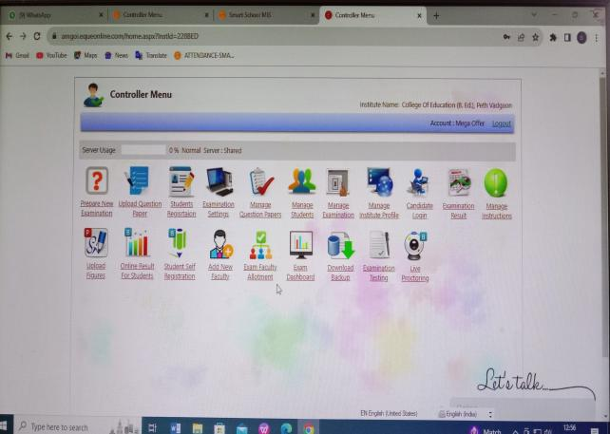

**Online Examination System Module Feature are as follows** -

1. Prepare new examination 2. Upload Question Paper 3. Students Registrion 4. Examination Setting 5. Manage Question Paper 6.Manage Institute Profile 7. Candidate Login 8. Examination Result 9.Manage Instruction 10. Upload figures 11. Online Result for students 12. Student self Registration 13. Add new faculty 14. Exam faculty allotment 15.Exam dashboard 16.Download Backup 17. Examination testing

**LEARNING MATERIAL DISTRIBUTION**

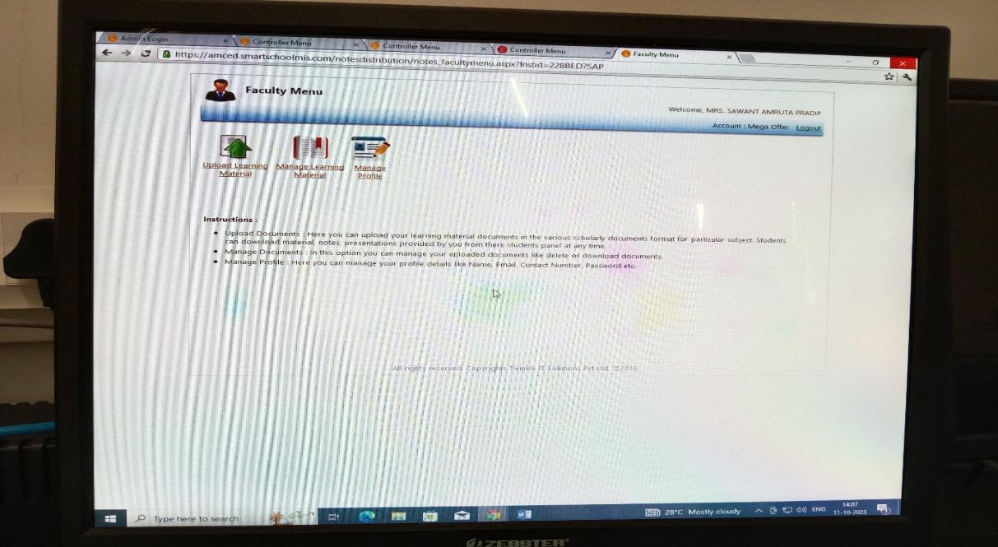

* Here Teachers can upload their learning material documents in the various scholarly documents format for particular subject. Students can download material, notes, presentations provided by you from there students panel at any time.
* In this option teachers can manage their uploaded documents like delete or download documents.
* Here teachers can manage their profile details like Name, Email, Contact Number, Password etc.

**SYLLABUS COVERAGE SYSTEM PORTAL**

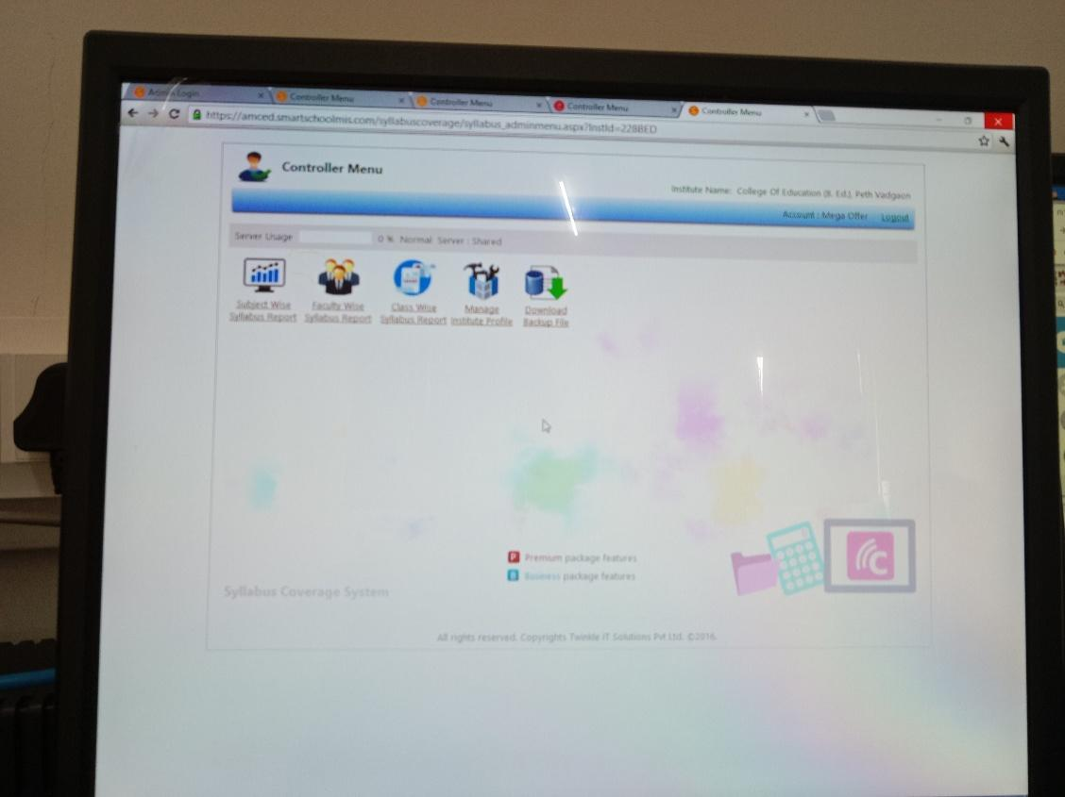

In this portal teachers can make the subject wise syllabus report, faculty wise syllabus report, class wise syllabus report. Teachers manage Institute Profile. Teachers download their backup files also.

**TEACHER GUARDIAN SYSTEM**

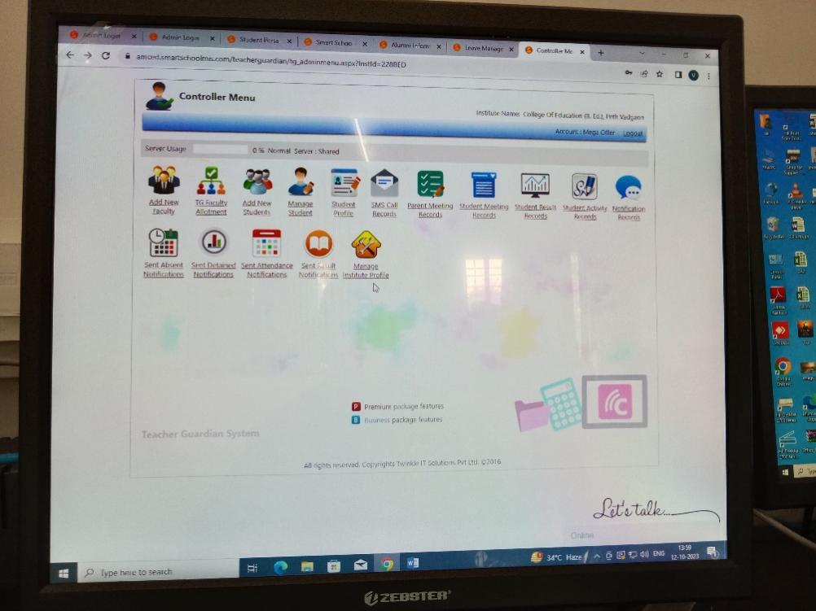

In teacher guardian system portal teachers can add new faculty. They can arrange teacher guardian faculty allotment. They can add new student, manage students and students profile. Teachers can maintain SMS call records, Parents Meeting records, Students Meeting Records, Notification Records, Students Activity Records and Students Results Records. Teachers can sent Absent Notifications, Detained Notifications, Attendance Notifications, Exam Result Notifications to students. Teachers manage Institute profile.

**E-NOTICE MANAGEMENT**

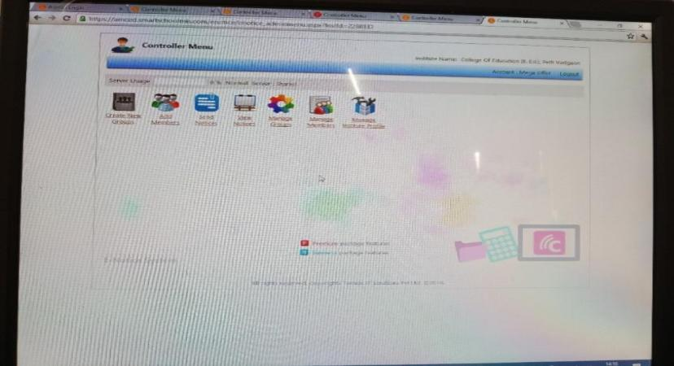

**E-Notice Management System portal features are as follows:**

**1.Create New Group 2. Add Members 3. Send Notices 4. View Notices 5.Manage Groups 6.Manage Members 7. Manage Institute Profile**

**2. ADMINISTRATION OFFICE MODULES**

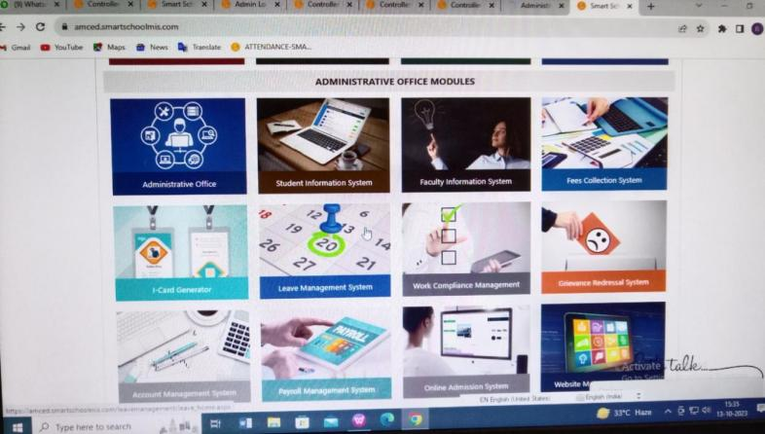

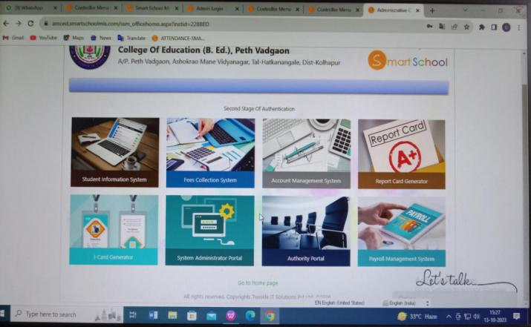

**Administrative Office Modules have Student Information System, Fees Collection System, Account Management System, Report Card Generator, ID Card Generator are sub portals.**

**2.1 STUDENT INFORMATION SYSTEM**

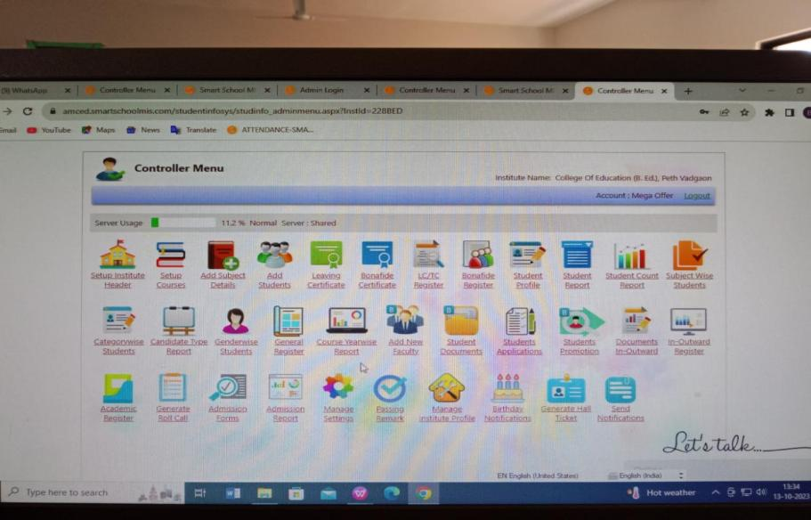

**Student Information system portal features are as follows:**

1. **Set up Institute Header 2. Set up Courses 3. Add subject Details 4. Add Students 5. Leaving Register 6. Bonafide Register 7. Student Profile 8. Student Report 9. Student Count Report 10. Subject wise Students 11. Category wise Students 12. Canditate Type Report 13.Gender wise students 14. Course Year wise Report 15. Add New Faculty 16. Student Documents 17. Students Applications 18. Students Promotions 19. Documents In- outward Register 20. In-Ourward Register 21. Academic Register 22. Generate Roll call 23. Admission Report 24. Send Notification etc**

**2.2 FACULTY INFORMATION SYSTEM**

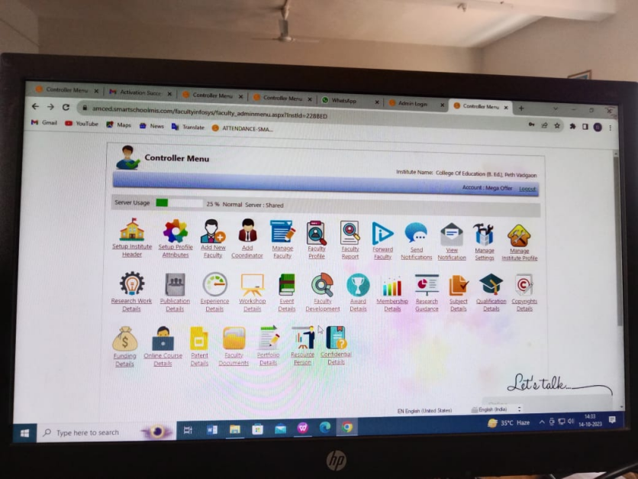

**Faculty Information system portal features are as follows:**

1. **Set up Institute Header 2. Set up Profile Attributes 3. Add New Faculty 4. Add Coordinatior 5. Manage Faculty 6. Faculty Profile 7. Faculty Report 8. Forward Faculty 9. Send Notifications 10. View Notification 11. Manage Setting 12. Manage Institute Profile 13. Research Work Details 14.Publication Details 15. Experience Detail 16. Workshop Details 17. Events Details 18. Faculty Development 19. Award Details 20. Membership Details 21. Research Guidance 22. Subject Details 23. Qualification Details 24. Copyrights Details 25. Funding Details 26. Online Coures Details 27. Patent Details 28. Faculty Documents 29. Portfolio Details 30. Resource Person 31.Confidential Details.**

**2.3 AUTHORITY**

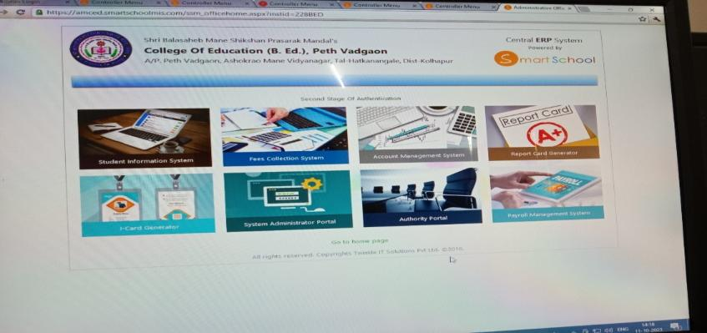

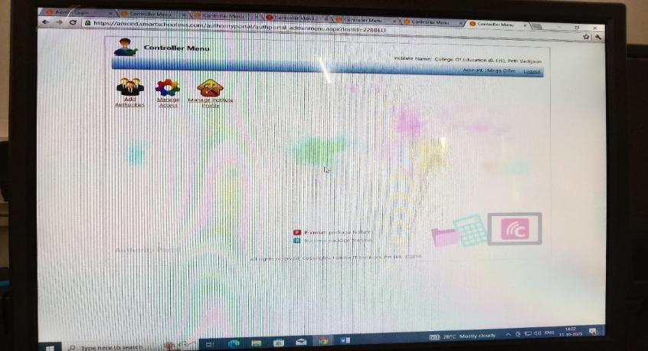

**Authority system portal features are as follows:**

**1.Add Authorities 2. Manage Access 3. Manage Institute Profile**

**2.4 GRIEVANCE REDRESSAL SYSTEM**

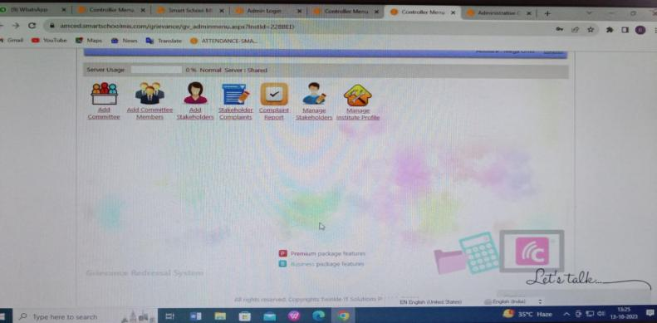

**Grievance Redressal System portal features are as follows:**

1. **Add Committee 2. Add Committee Members 3. Add Stakeholders 4. Stakeholder Complaints 5. Complaint Repot 6. Manage Stakeholders 7. Manage Institute Profile**

**3. OTHER MODULES**

**In other modules Alumni Information system portal, Training and Placement portal, Hostel Management System portal, Transport Management system portal, Library Management system and Alumni Portal these are sub portal. These modules are useful for alumni records, library management, transport system, hostel management etc.**

**3.1 ALUMNI PORTAL**

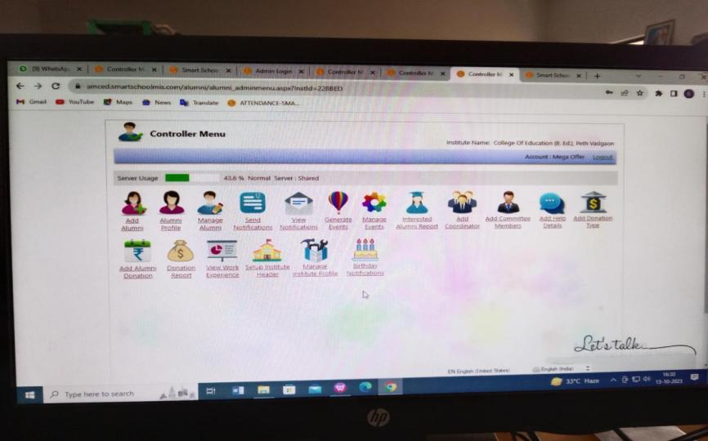

**Alumni Information System portal features are as follows:**

1. Add Alumni 2. Alumni Profile 3. Manage Alumni 4. Send Notification 5. View Notifications 6. Generate Events 7. Manage Events 8. Interested Alumni Report 9. Add Coordinator 10. Add Committee members 11.Add help Details 12. Add Donation Type 13.Add Alumni Donation 14. Donation Report 15.View work experience 16. Setup Institute Header 17. Manage Institute Profile 18. Birthday Notification.

**3.2 TRAINING AND PLACEMENT**

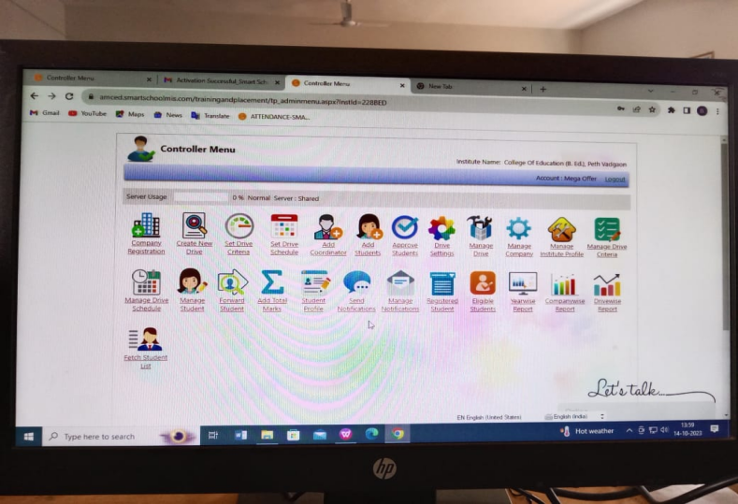

**Training and Placement portal features are as follows:**

1. Company Registration 2. Create New Drive 3. Set Drive Criteria 4. Set Drive Schedule 5. Add Coordinatior 6. Add Students 7. Approve Students 8. Drive Settings 9. Manage Drive 10. Manage Company 11. Manage Institute Profile 12. Manage Drive Criteria 13. Manage Drive Schedule 14. Manage Students 15. Forward Students 16. Add Total Marks 17. Student Profile 18. Send Notifications 19. Manage Notifications 20. Registered Students 21. Eligible Students 22. Year wise Report 23. Company wise Report 24. Drive wise Report 25. Fetch Student List

**3.3 TRANSPORT MANAGEMENT PORTAL**

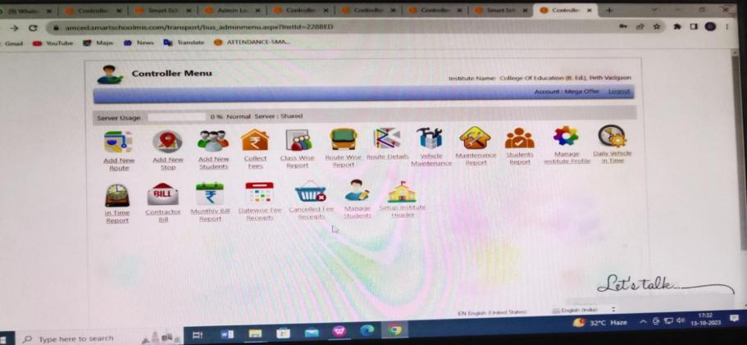

**Transport Management System portal features are as follows:**

1. Add new route 2. Add new stop 3. Add new students 4. Collect Fees 5. Class wise Report 6. Route wise Report 7. Route Details 8. Vehicle Maintenance 9. Maintenance Report 10. Student Report 11. Daily Vehicle In Time 12.In time Report 13.Contractor Bill 14. Monthly Bill Report 15. Date wise fees Receipts 16. Canceled Fee Receipts 17. Manage Students 18. Set up Institute Header

**4. STUDENT PORTALS**

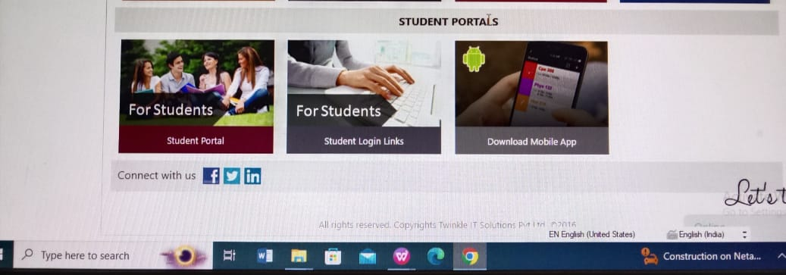

**4.1 STUDENT PORTAL**

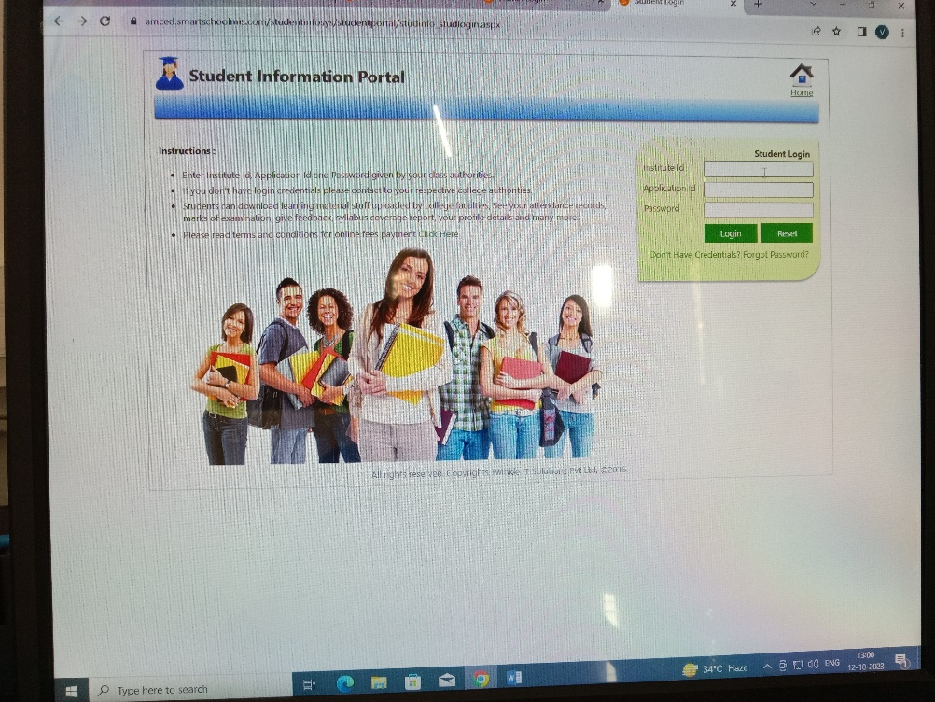

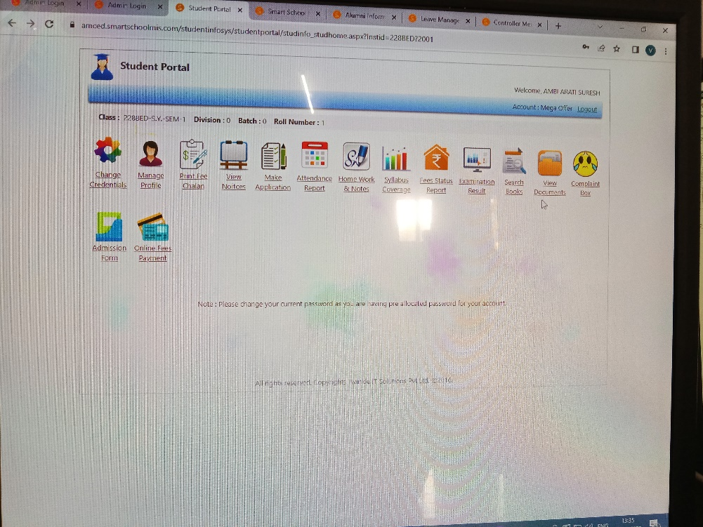

In this portal student received instruction by Teachers, librarian and other staff members. They can also see learning material links, pdf, You Tube channel links, Syllabus links, etc distributed by teachers. They can received E-Notices by Authority, Teachers, Librarian and other staff members. Students change their own credentials. They can manage their profile. Students print their fee chalan. Students make applications. They can see their attendance reports, Homework and Notes, Syllabus coverage. Students see their fees status reports, examination results. They can search books. They can compliant in complaint box. They can fill admission form. Students paid fees through online payment.

**4.3 DOWNLOAD APP**

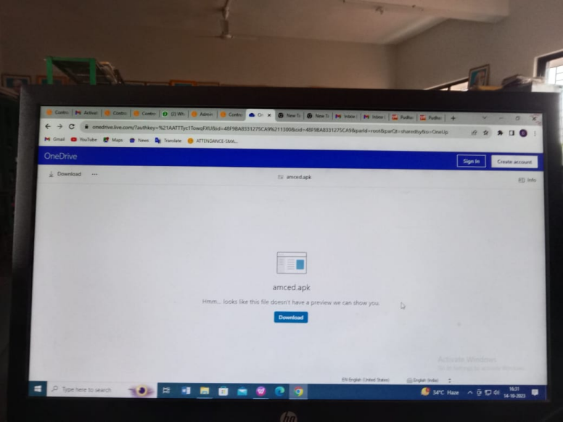

Students download app on there smart phones, laptop, PC etc. MIS Software is a Cloud based application which focuses on the skill development and easy learning methods for students. It consists of interesting educational games for students like home work and test series on each topic of syllabus or other than syllabus. Parents of any ward can see their ward's progress reports and marks of test exams, his/her attendance records using mobile app. Faculties can add topic wise homework, topic wise spellings, vocabulary for practice. Students can do their home work from parents mobile app.

