6.5.2

A workshop on Model of Teaching Aid was conducted in our College of Education under IQAC

A Model of Teaching workshop was conducted in our B.Ed college .Models of Teaching workshops as part of its ongoing efforts to improve the quality of teacher education. These workshops were conducted over a period of six months, targeting B.Ed students, with the primary goal of enhancing their teaching skills and preparing them for effective classroom instruction.

The main objectives of the workshops were as follows:

* To familiarize B.Ed students with various teaching models and their practical applications.
* To enhance classroom management and instructional strategies.To encourage innovative teaching approaches.
* To assess the impact of these workshops on the students’ pedagogical skills.

Improvement was observed in participants

* Significant improvement was observed in participants’ understanding of teaching models and their ability to apply them in the classroom.
* Participants reported increased confidence in managing classrooms and handling diverse student groups.
* Innovative teaching approaches, such as active learning and technology integration, were embraced and effectively implemented.
* Post-workshop assessments indicated higher scores in lesson planning, content delivery, and student engagement.
* Feedback from students indicated a higher level of satisfaction with their own teaching abilities and the quality of education they received.

Thus there was an increment in teaching among the students .highlights the positive impact of Models of Teaching workshops on B.Ed students, emphasizing the importance of ongoing professional development for future educators.

Select Appropriate Teaching Aids: Choose teaching aids that align with the subject matter and learning goals. Different subjects may require different types of aids:

* Visual Aids: Use charts, diagrams, graphs, and multimedia presentations for subjects like Science, Geography, or History.
* Models and Demonstrations: Utilize physical models or experiments for subjects like Science
* Audio-visuals Aids: Employ videos, simulations, and online resources for languages, mathematics, or any subject where visual and auditory learning is beneficial.
* Manipulative Aids: For subjects like Mathematics, provide students with hands-on materials like math manipulatives or puzzles.Textbooks and Supplementary Materials: Ensure access to relevant textbooks, workbooks, and supplementary materials for in-depth study.

**Psychological Test**

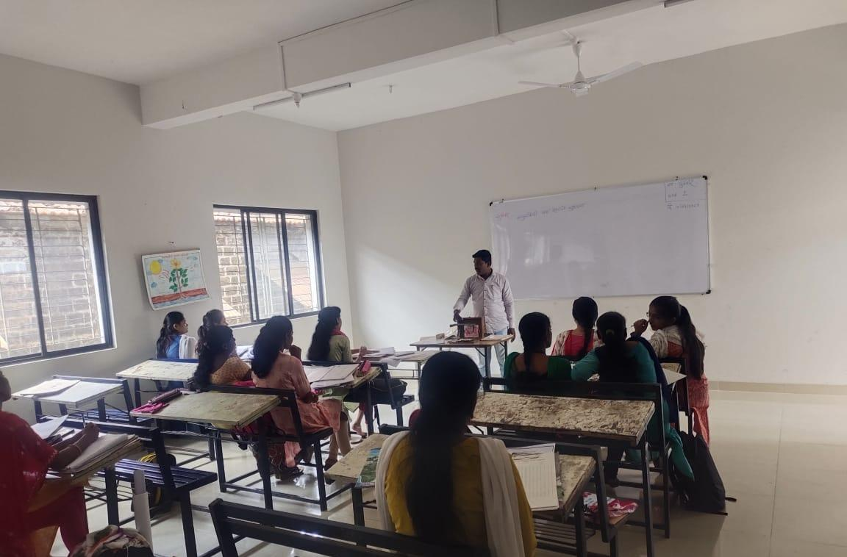

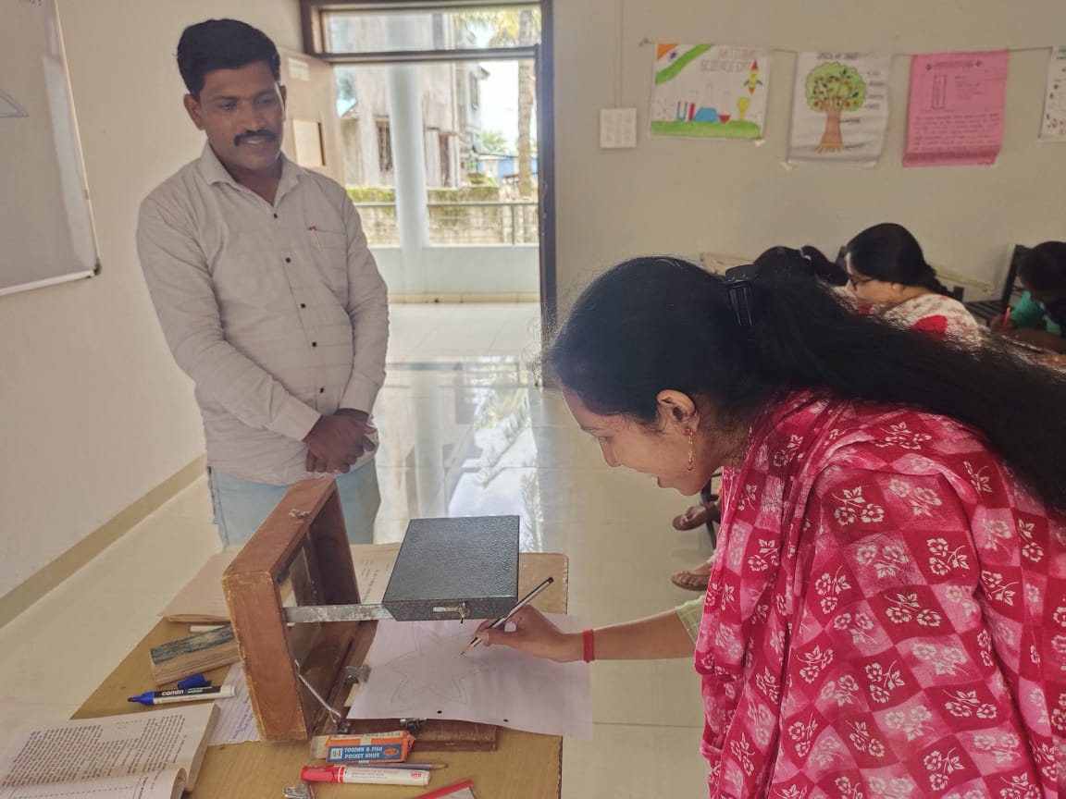



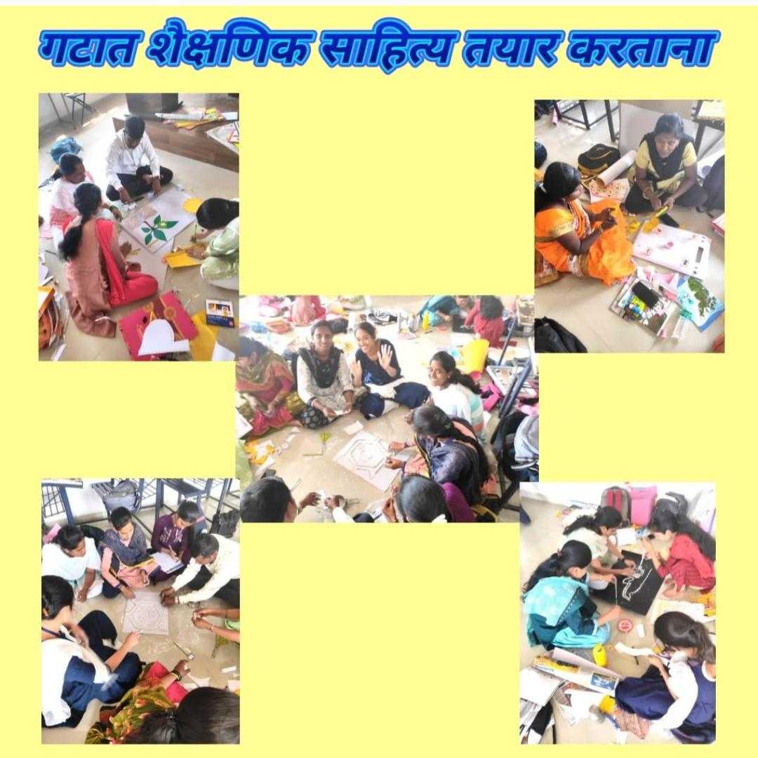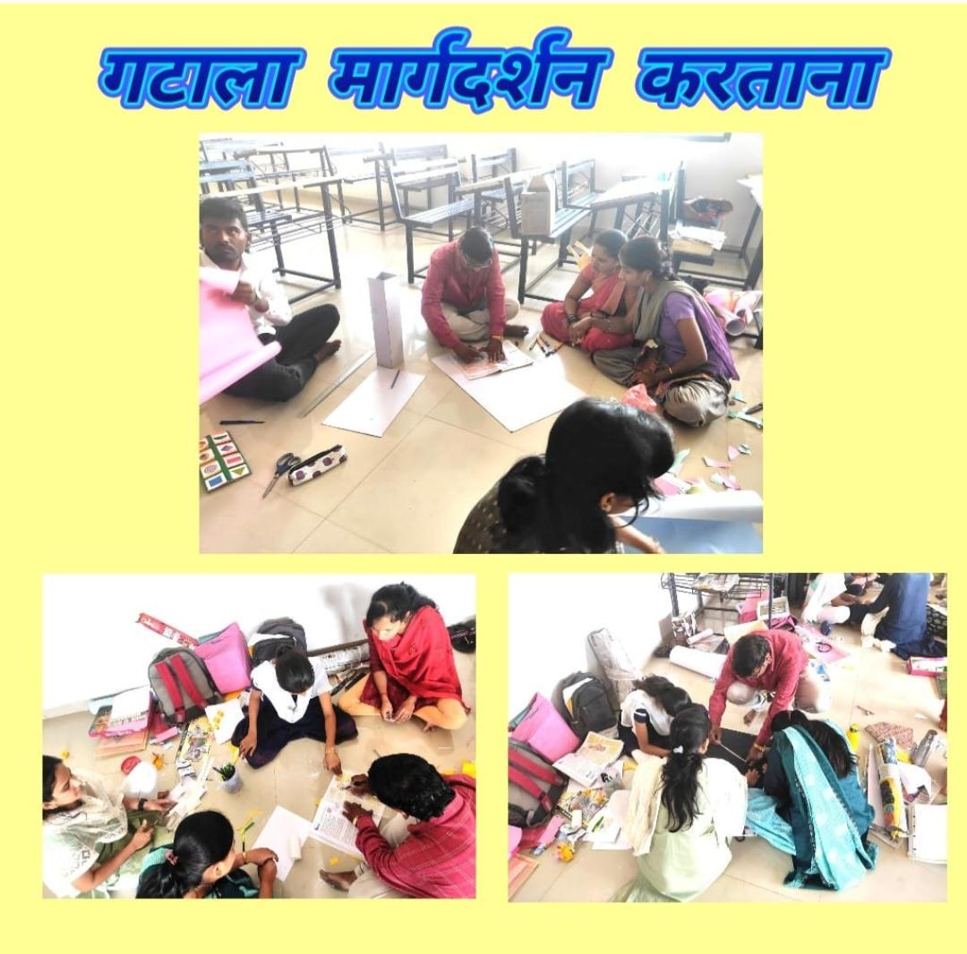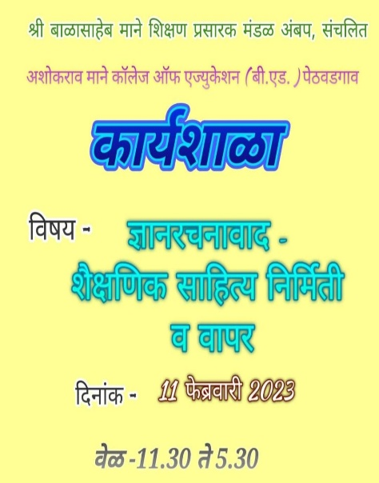**Teaching Aid Workshop**