**6.3.4**

**College of Education (B.Ed.) Peth Vadgaon**

**TEACHER ORIENTATION PROGRAMME**

**Teacher orientation programme organized at College of Education B.Ed Peth Vadgaon on 5th June 2023 for all the faculty. Principal R.L.Nirmale madam guided about curriculum transaction in pandemic situation and coordinator Prof. Shirtode V.L. disseminated the information about how to face NAAC.**

* **Principal R. L.Nirmale oriented about curriculum transaction**

**IQAC coordinator Prof. Shirtode V.L. has oriented about the following points**

* **List of teachers**

|  |  |
| --- | --- |
| **Sr**.**No** | **Name** |
| **1** | I**/**C pri.Nirmale.R.L |
| **2** | Assi.pro.Sorte.S.k |
| **3** | Assi.pro.Shirtode.V.L |
| **4** | Assi.pro.Sawant.A.P |
| **5** | Assi.pro.Powar.A.R |
| **6** | Assi.pro.Mujawar.S.A |
| **7** | Assi.pro.Charankar.J.S |
| **8** | Assi.pro Habale.A.K |

* **List of Non- teaching staff**

|  |  |
| --- | --- |
| **Sr.No** | **Name** |
| 1 | Chavan.R.R |
| 2 | Chougule.S.S |
| 3 | More S.P |
| 4 | Smt.chougule.S.S |
| 5 | Smt.Patil.P.V |
| 6 | Kamble.B.B |
| 7 | Dhangar.P.T |
| 8 | Suryavanshi.P.V |
| 9 | Mane.D.S |
| 10 | Dongare.P.J |

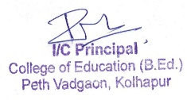

**Student Name list**

**B.Ed-2022-23**

**B.Ed-I**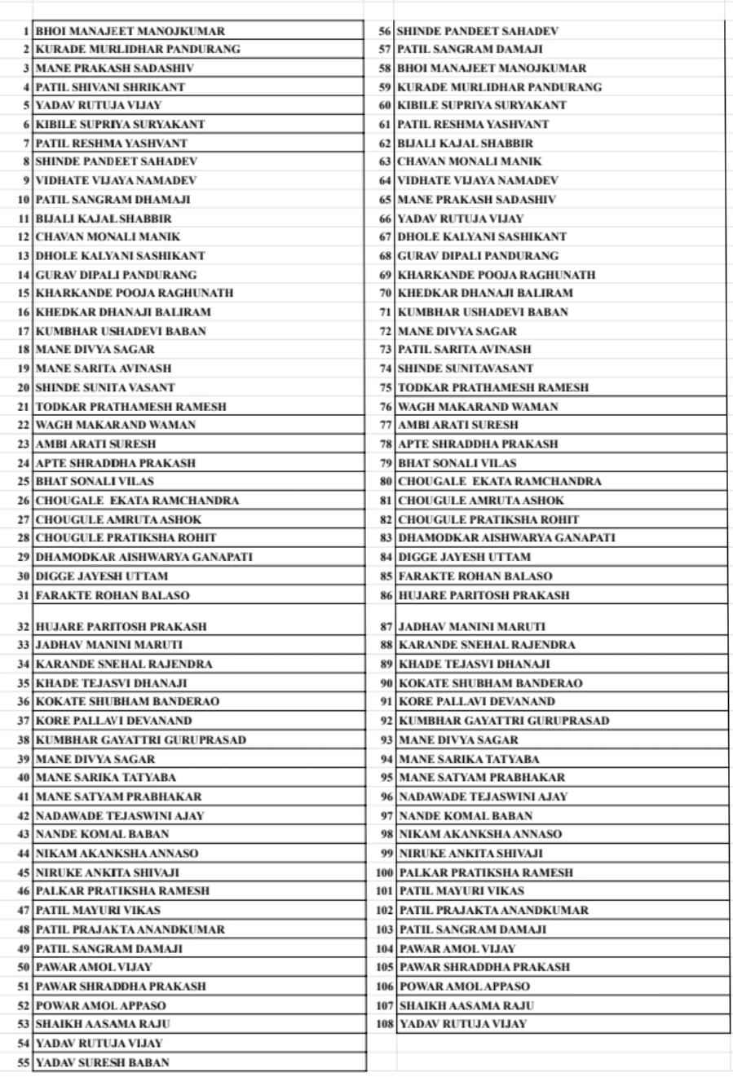

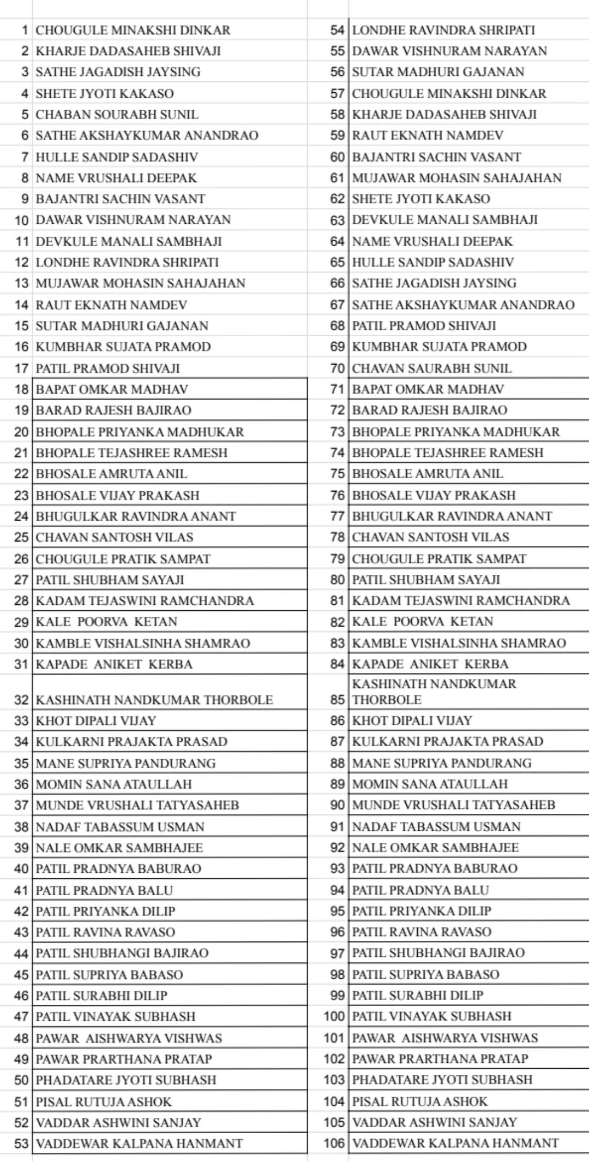**B.Ed-II**

