Shri Balasaheb Mane Shikshan Prasarak Mandal Ambap’s

**College of Education (B.Ed.) Peth Vadgaon**

**TEACHER ORIENTATION PROGRAMME**

**REPORT**

Teacher orientation programme organized at College of Education B.Ed Peth Vadgaon on5th June 2023 for all the faculty. Principal R.L.Nirmale madam guided about curriculum transaction in pandemic situation and coordinator Prof. Shirtode V.L. disseminated the information about how to face NAAC.

Principal R. L.Nirmaleoriented about curriculum transaction which includes following points

1) Preparing time table for teaching.

2) Preparing year plan.

3) Change in session and duration of semester.

IQAC coordinator Prof. Shirtode V.L. has oriented about the following points

1) About NAAC process

2) AQAR feeling process

3) Required documents for AQAR.

4) IIQA feeling process.

5) Changing role of colleges in NAAC accreditation.

Both speakers gave an important information regarding above subjects that creates insight among the faculty members and motivate to work hard.

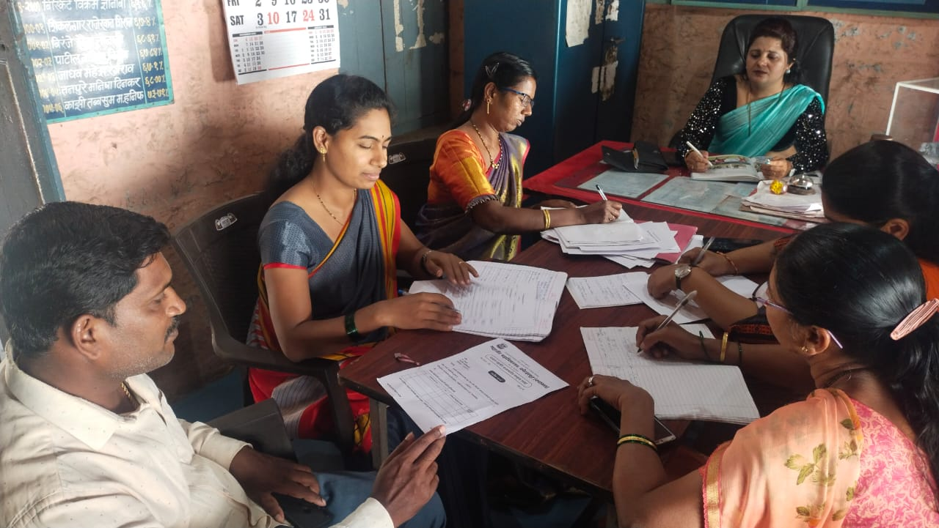

Shri Balasaheb Mane Shikshan Prasarak Mandal Ambap’s

**College of Education (B.Ed.) Peth Vadgaon**

Smart School MIS software training programme

**REPORT**

**Topic -** Smart school MIS software training programme for all teaching and non – teaching staff.

On 4th September 2023 our college organized “Smart school MIS software training programme” for teaching and non teaching staff. In this programme we invited Mr. Bodake sir for training the teachers and non teaching staff to use MIS Software. He explained all the features of MIS with demonstration. Explain how to use software, how to create login and password of student and teachers, how to upload students presenty, all notifications, syllabus, notes, study material on the MIS software.

After the presentation all staff started using the MIS. At that time Mr. Bodake sir solved all the problems related to login and other aspects. Throughout the day all faculty became familiar with MIS Software. Our Principal R.L.Nirmale madam give presidential views. This program ended with vote of thanks by Prof.Sorte sir.

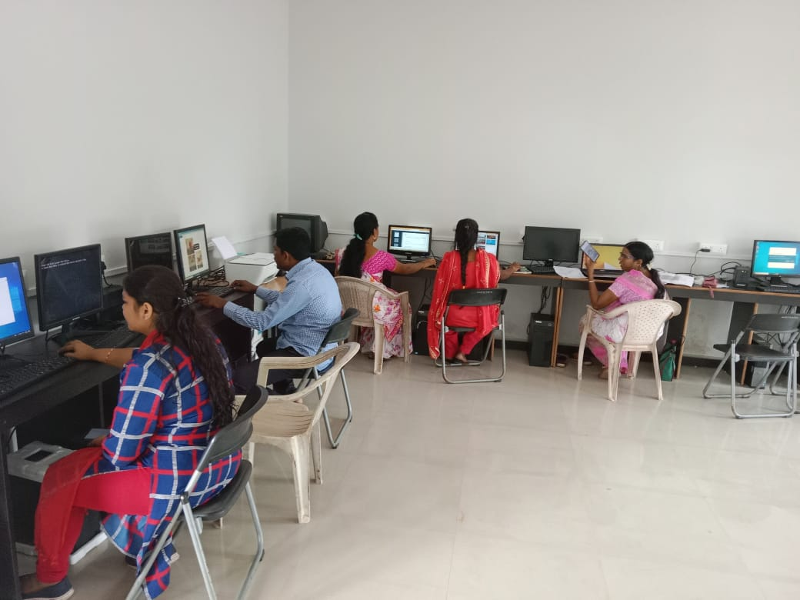

**All staff using the MIS**

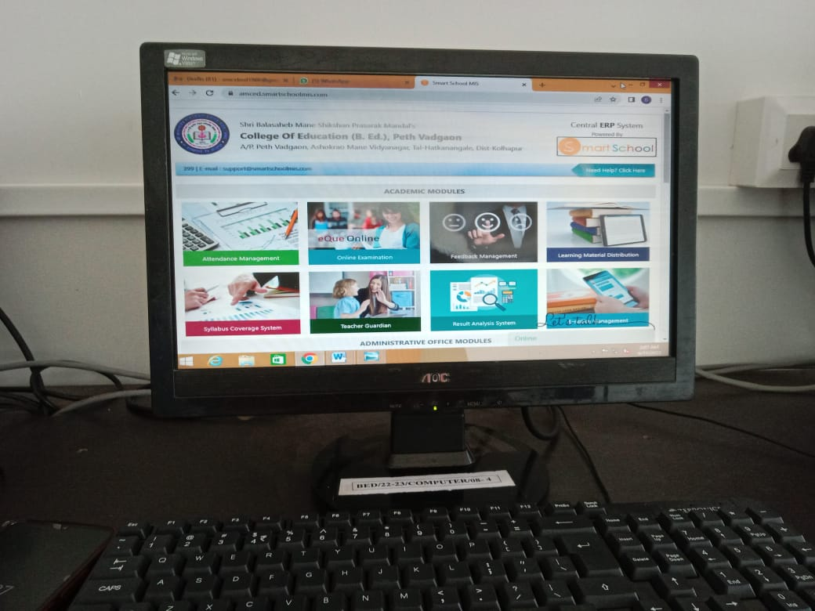

Shri Balasaheb Mane Shikshan Prasarak Mandal Ambap’s

**College of Education (B.Ed.) Peth Vadgaon**

College Website Training Programme

**REPORT**

**Topic –**College website training programme for all teaching staff.

On20th June 2023 our college organized “College website training programme” for teaching staff. In this programme, we invited Mr.Vijay Mole sir Dream computer, Kolhapurfor training the teachers. He explained all the features ofwebsite with demonstration. Explain how to create link, how to upload pictures, how to upload video, to make webpage on college website.

After the presentation all staff started using the website. At that time Mr.Vijay Mole sir solved all the problems related to website and other aspects. Throughout the day all faculty became familiar with webste. Our Principal R.L.Nirmalemadam givespresidential views. This program ended with vote of thanks by Prof. charankar madam.