6.3.1

Our college is a non grant college. Our college have a Servant's Co-operative Credit Society

All the servants working in our college are benefited by the credit institution which is the credit institution of our college.In a cooperative credit institution, employees or servants may have deductions from their salaries for group insurance. Group insurance provides coverage for employees in case of accidents, illness, or other unforeseen events. The deductions are usually a percentage of the employee’s salary.

Additionally, some institutions may have medical funds or health insurance schemes that employees can contribute to through deductions from their salaries. These funds are used to cover medical expenses, such as doctor’s visits, hospitalization, or prescription medications. Again, the deductions are typically a percentage of the employee’s salary.

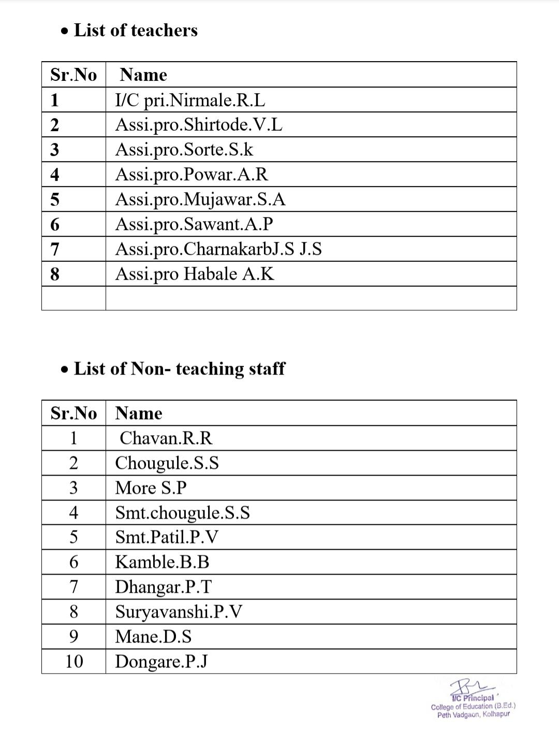**List of beneficiaries-**

* **Ashokarao Mane shikshan samuh sevakanchi sahkari Patha Sansthamaryadit,**

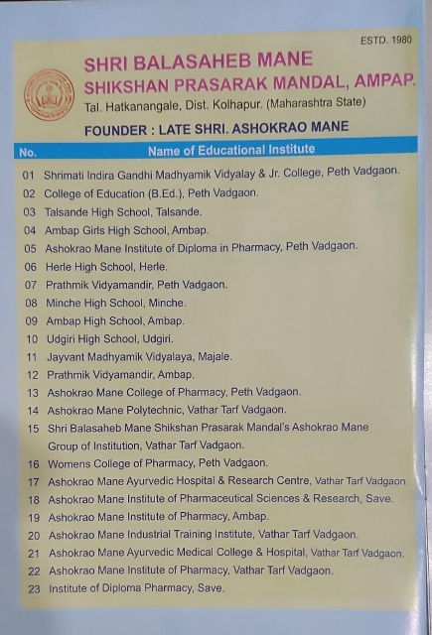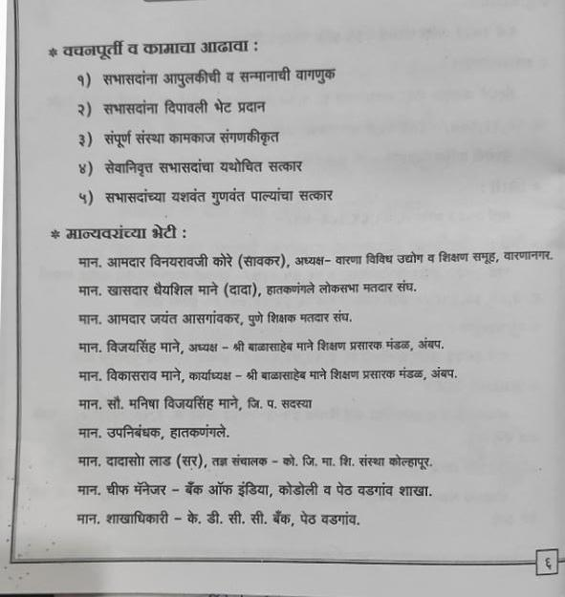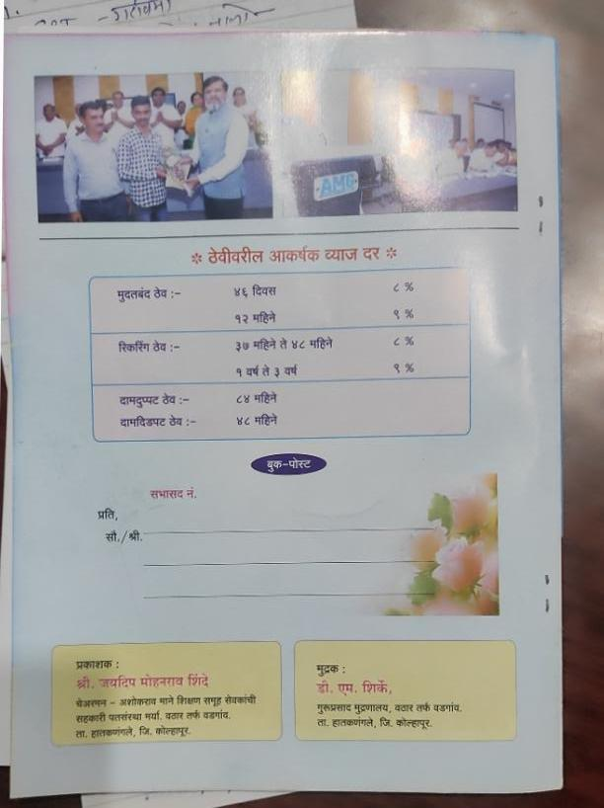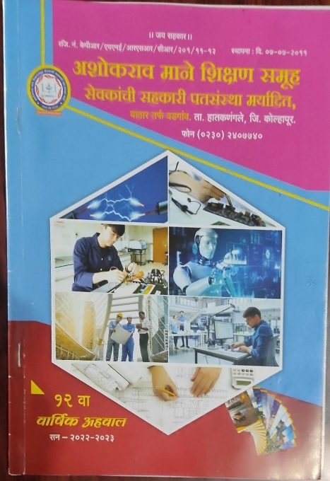**Wathar Tarf Vadgaon**

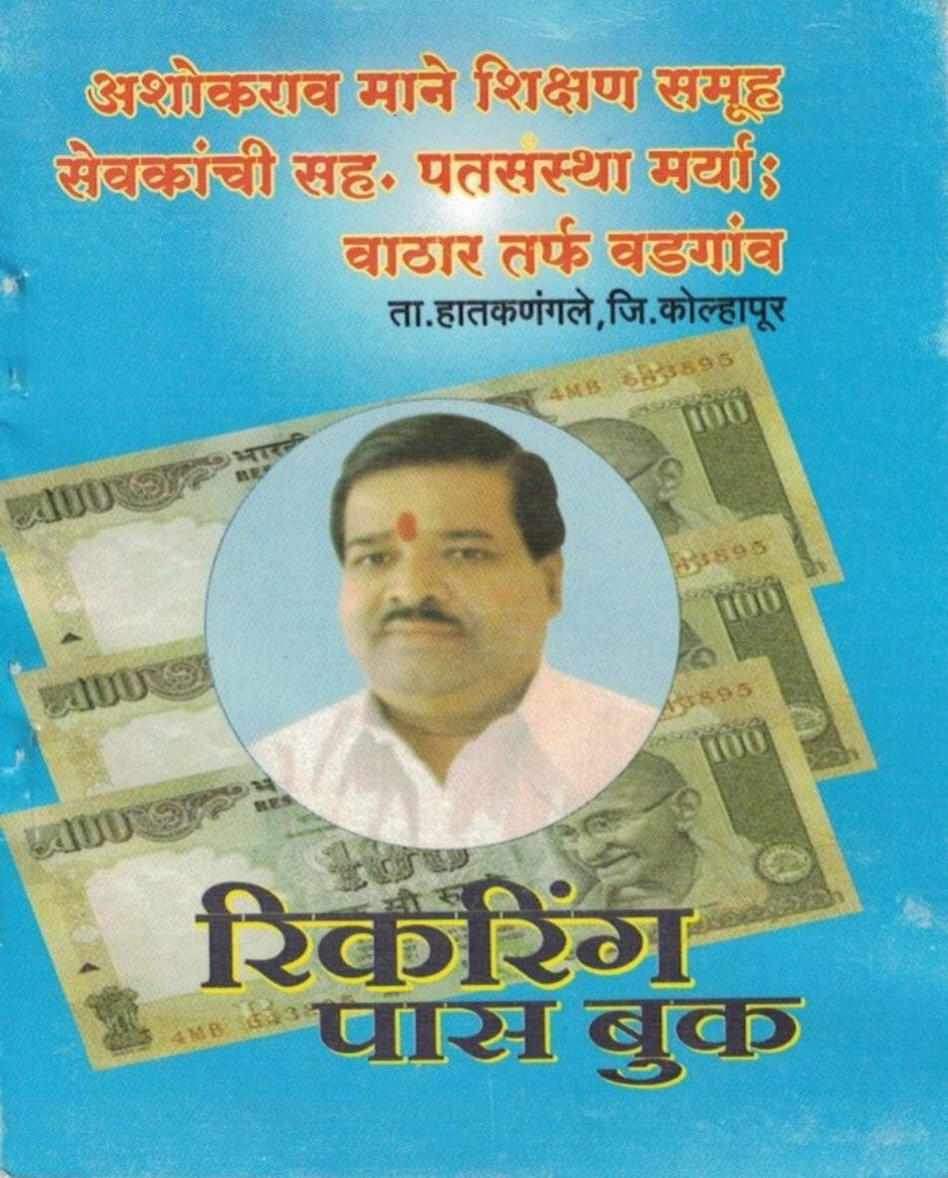

**Recurringpassbook**

