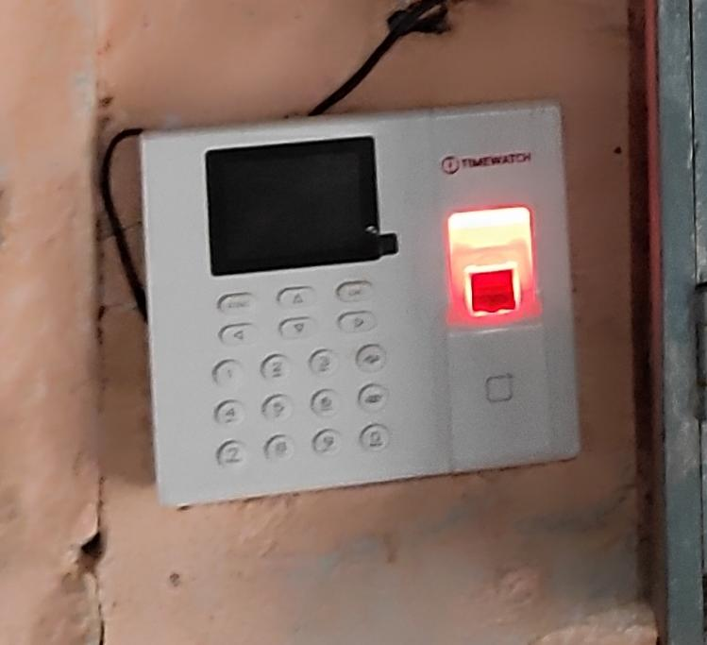6.2.3 **Biometric machine**

**Biometric attendance is usually taken at the beginning of the morning 11 am and ending time 5.00 pm**

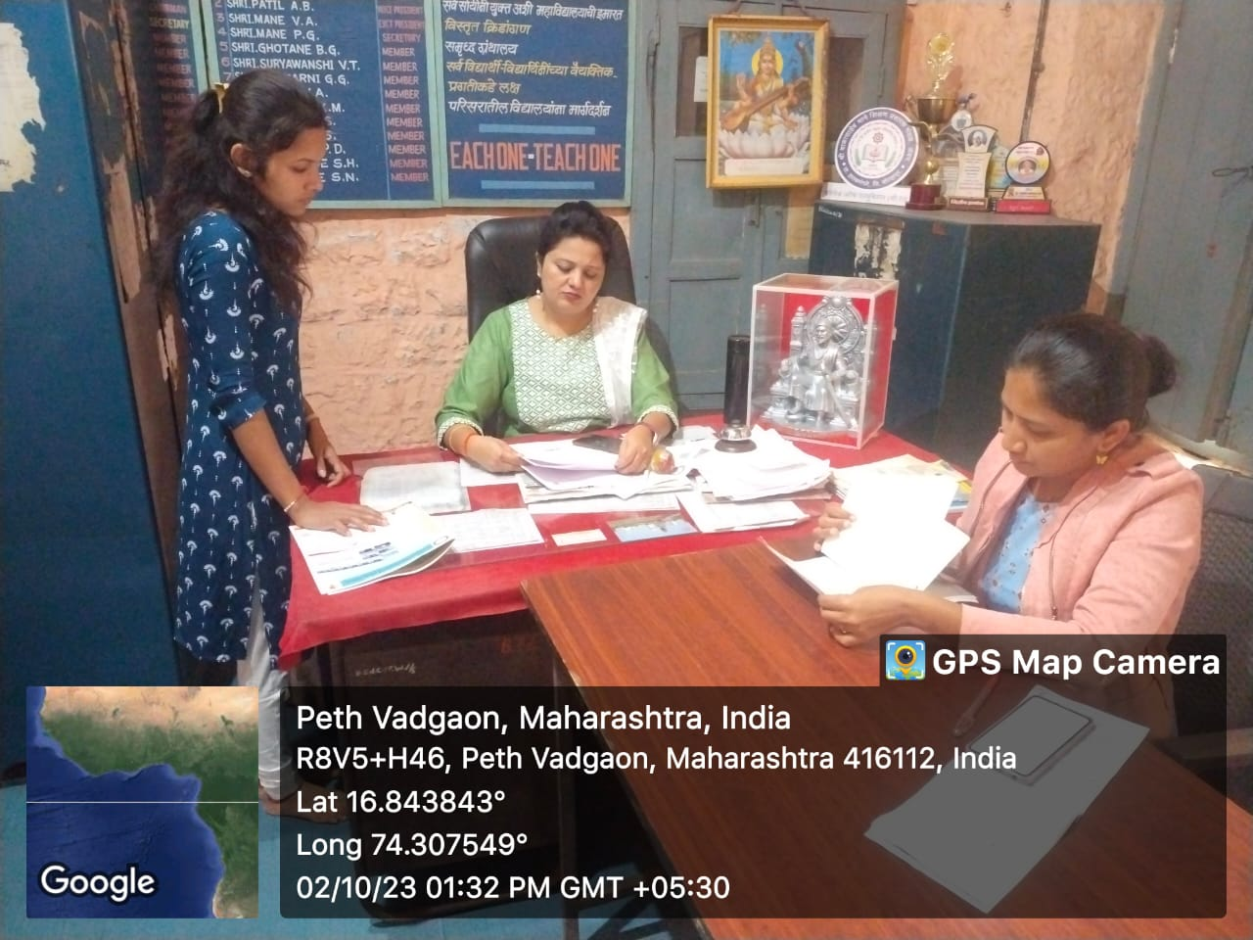

**Admission Process**

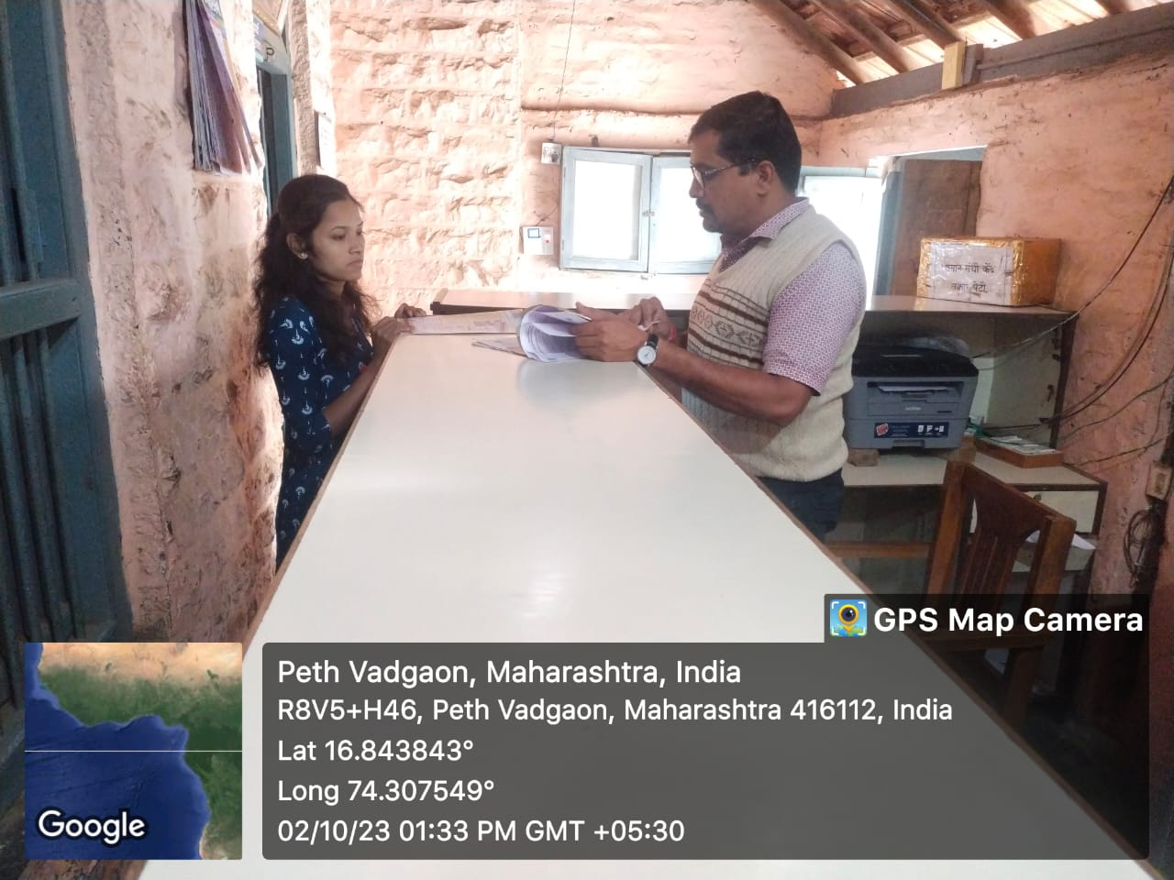

**Office**

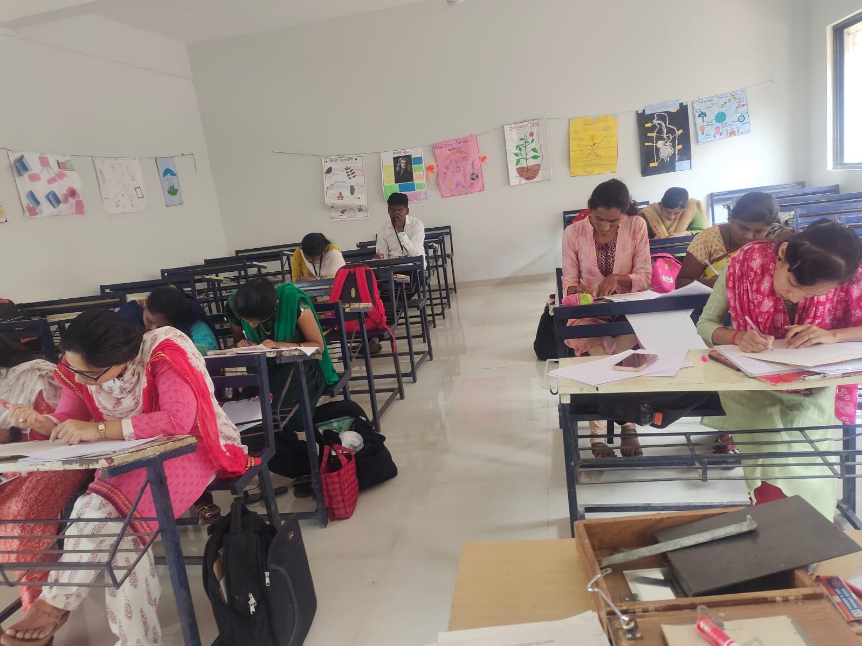

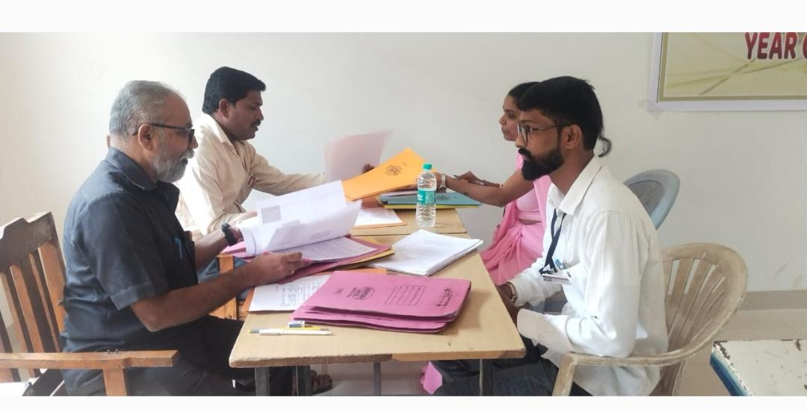

**Examination**

**Examination**