6.1.2

In our B.Ed college of education, PethVadgaon various committees play essential roles in managing and ensuring the smooth functioning of the institution.

These committees typically consist of faculty members and administrators, and their composition and responsibilitiesmay vary from one B.Ed college to another.Decisions are taken democratically in every committee Their collective efforts ensure that the college provides a high-quality education and supportive environment for aspiring teachers.

* 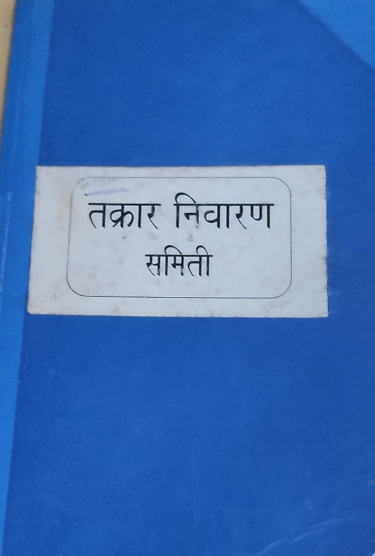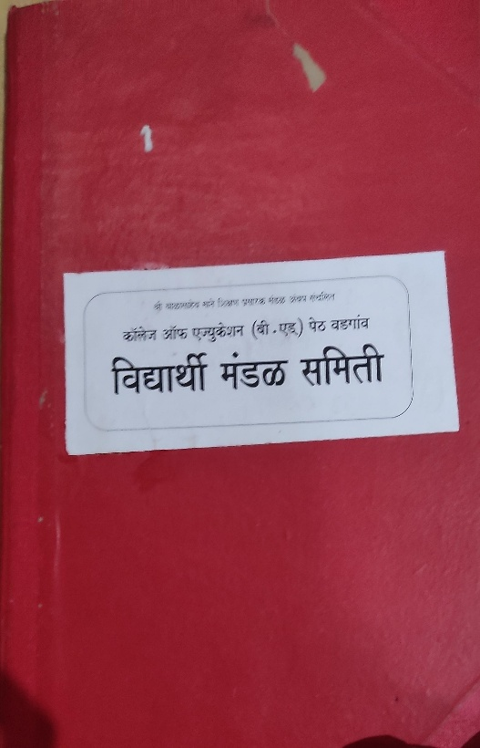committees-

