**6.1.1**

Shri Balasaheb Mane Shikshan Prasarak Mandal Ambap was established in 1980. The organization has more than 25 branches. ShriBalasaheb Mane Shikshan Prasarak Mandal Ambap,Sanchalit College of Education Peth vadgaon was established in 1986 by Late Mr. Ashokarao Mane Saheb.This college has imparted enough knowledge to the students in thirty six years and is working hard for their overall development.Honorable I/c Principal of this college Mrs. R. L. Nirmale and all the teaching and non-teaching staff of the college are working for the development of the college and students. Along with the curriculum, co-curricular activities are conducted, various activities are conducted, various competitions are conducted, through which the overall development of the students takes place, a pleasant atmosphere, teacher-student interaction, cooperation.

The result of all these factors is the current number of students in the colleges. College students excel in sports as well as in various fields with the latent qualities of each student scope is given. As a result, the quality and status of the college is progressing. Every student passing out of this college is working in various fields at a great position. In 2017 - 2018 year students was very less compared to the present in year 2021, 2022.2023. Considering the number of students this year, the reason for this increase is seen because the inspiration for the college is the Principal Nirmale.R.L Madam.

**Vision Statement:**

"To be a pioneering institution of excellence in teacher education, dedicated to nurturing the holistic development of future educators, fostering innovation in pedagogy, and promoting research-driven practices to meet the evolving educational needs of society."

**Mission Statement:**

**Quality Pedagogy:**

"Our mission is to provide high-quality teacher education through innovative pedagogical approaches, ensuring that our graduates are equipped with the knowledge, skills, and values required to inspire and educate learners effectively."

**Research and Development:**

"We are committed to fostering a culture of research and development among faculty and students, encouraging them to engage in research activities that contribute to educational advancements and pedagogical excellence."

**Inclusivity and Diversity:**

"We strive to create an inclusive and diverse learning environment that celebrates differences, promotes equity, and prepares our graduates to be culturally sensitive and socially responsible educators."

**Community Engagement:**

"We aim to engage with the local community and educational stakeholders, fostering partnerships and collaborations that enrich the learning experience of our students and contribute to the betterment of education in our region."

**Community development programme :**

"Gain experience with the child, the community and the school through the School

Engagement and School Internship programme."

**Goals of our Institution –**

1. Developing teaching skills

2. Gaining subject knowledge

3. Learn strategies for maintaining a positive learning environment.

4. Exploring various teaching methods and strategies.

5. Professional growth: Preparing for a successful career in education.

6. Building a network: Connecting with educators and peers for collaboration and support.

7. Staying updated on educational trends and research.

8. Fulfilling the requirements to become a certified teacher.

9. Making a positive impact.

10. Lifelonglearning: Cultivate a commitment to continuous self – improvement and growth as a

teacher.

**The student teachers personal objectives -**

1. To promote capabilities for including national values and goals as enshrined in

the constitution of India

2. To prepare professionally competent teacher to perform their roles as a teacher at the

secondary and higher secondary stage.

3.To develop understanding about children of different age groups, through close observation

and interaction with children from diverse socioeconomic and cultural backgrounds.

4.To appreciate that all teaching is directed at learning, and that the learner is at the heart of

teaching.

6. To understand teaching as complex activity and as profession.

7. To develop understanding of student-teachers about themselves – the development of the self

as a person and as a teacher, through conscious ongoing reflection.

8. Gain experience with the child, the community and the school through the school

engagement and school internship programme.

**The student teachers Social Objectives -**

1)Cultural Sensitivity: Encouraging student teachers to develop an understanding and appreciation of

diverse cultures, languages, and backgrounds to create an inclusive classroom environment.

2) Effective Communication: Teaching effective communication skills to facilitate better interaction

withstudents, parents, colleagues, and the community.

3) Community Engagement: Encouraging student teachers to actively participate in community events

and engage with parents to create strong ties between the school and the local community.

4) Ethical Behavior: Promoting ethical behavior and professional conduct among student teachers,

emphasizing the importance of integrity, fairness, and respect.

5) Social Responsibility: Encouraging a sense of social responsibility among student teachers by

discussing issues like social justice, equity, and the role of education in addressing societal challenges.

**Curriculum Planning Methods**

First we prepare the academic calendar and hold a general meeting to distribute the syllabus to everyone and then take the meeting to see how many courses have been completed and if there is a small amount of courses left uncompleted. Those teachers are given extra hours. We get the syllabus for this from Shivaji University Kolhapur. We also get the terms university and after getting that term, we distribute the work of that semester and complete it in that time. Only later our exams take place in which the first year exam is done at college level and its papers are checked in college but that exam is conducted by university and evolution of second year examination conducted by university.

* **List of teachers**

|  |  |
| --- | --- |
| **Sr**.**No** | **Name** |
| **1** | I**/**C pri.Nirmale.R.L |
| **2** | Assi.pro.Sorte.S.k |
| **3** | Assi.pro.Shirtode.V.L |
| **4** | Assi.pro.Sawant.A.P |
| **5** | Assi.pro.Powar.A.R |
| **6** | Assi.pro.Mujawar.S.A |
| **7** | Assi.pro.Charankar.J.S |
| **8** | Assi.pro Habale.A.K |

* **List of Non- teaching staff**

|  |  |
| --- | --- |
| **Sr.No** | **Name** |
| 1 | Chavan.R.R |
| 2 | Chougule.S.S |
| 3 | More S.P |
| 4 | Smt.chougule.S.S |
| 5 | Smt.Patil.P.V |
| 6 | Kamble.B.B |
| 7 | Dhangar.P.T |
| 8 | Suryavanshi.P.V |
| 9 | Mane.D.S |
| 10 | Dongare.P.J |

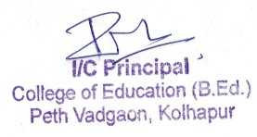

**Student Name list**

**B.Ed-2022-23**

**B.Ed-I**

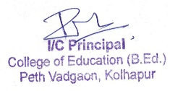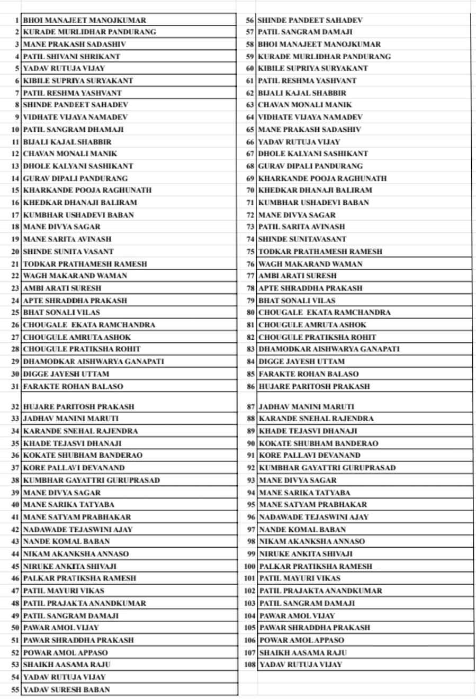

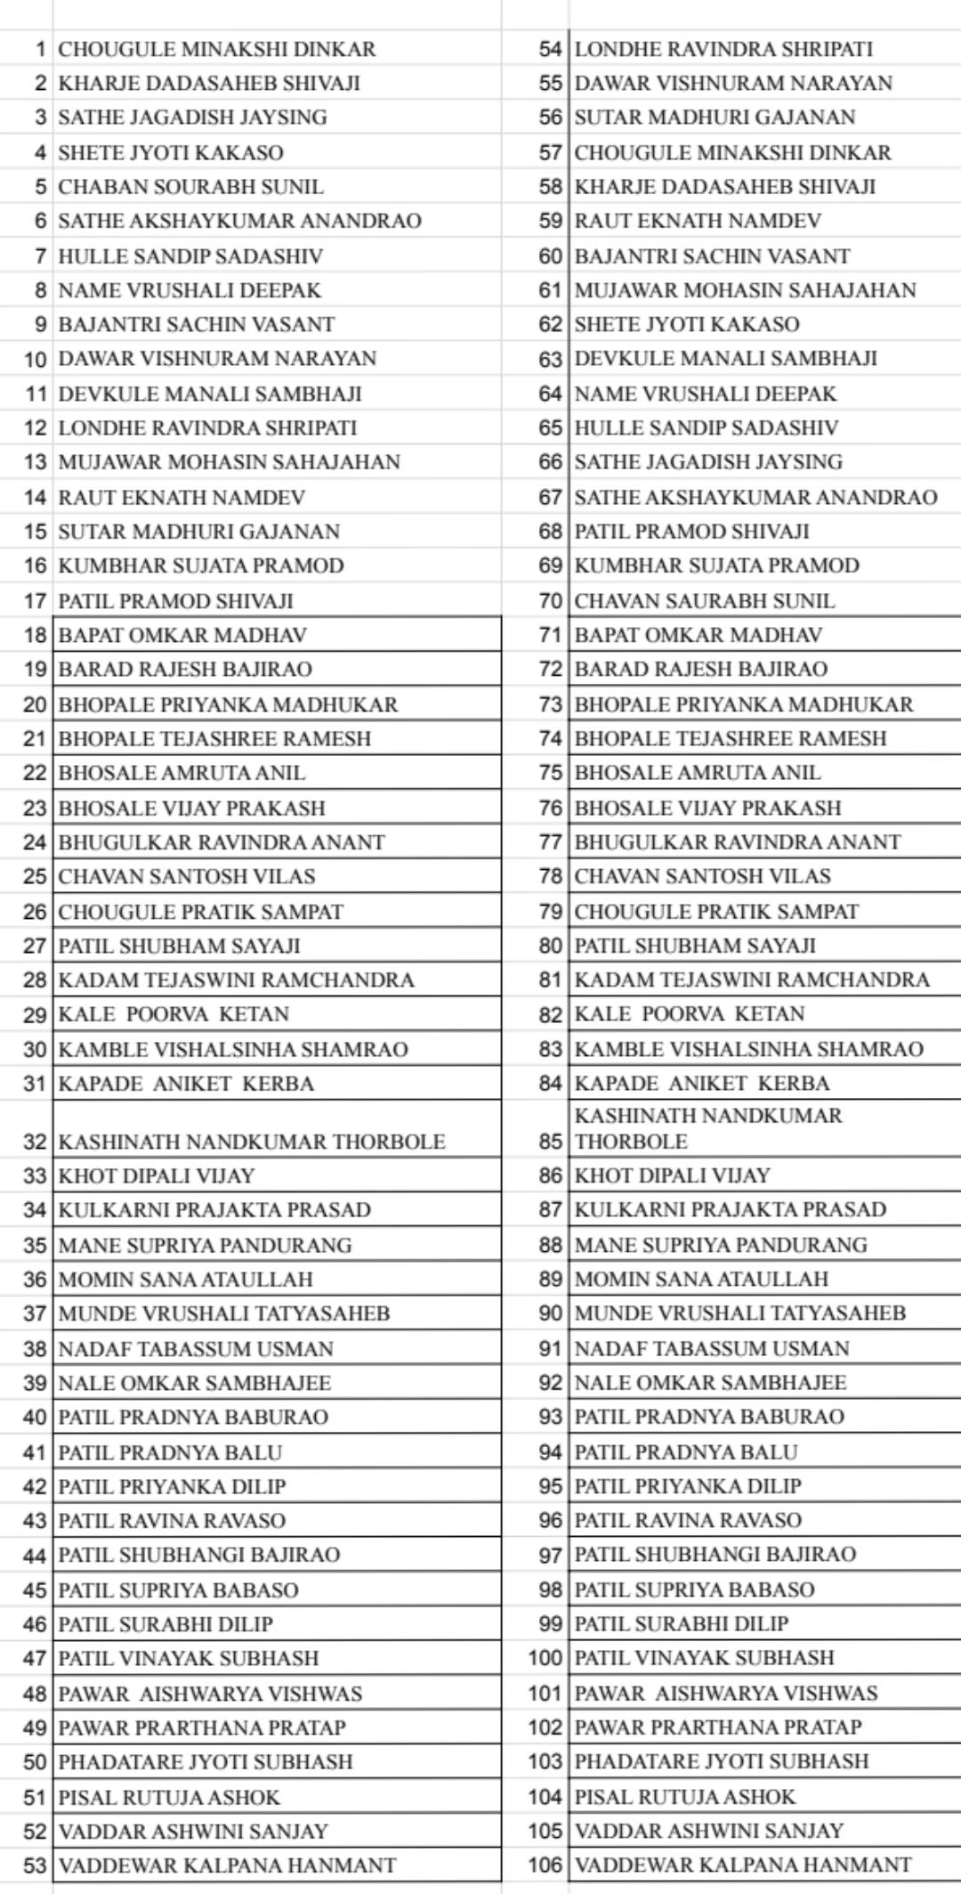**B.Ed-II**

