**6.1.1**

* **List of teachers**

|  |  |
| --- | --- |
| **Sr**.**No** | **Name** |
| **1** | I**/**C pri.Nirmale.R.L |
| **2** | Assi.pro.Sorte.S.k |
| **3** | Assi.pro.Shirtode.V.L |
| **4** | Assi.pro.Sawant.A.P |
| **5** | Assi.pro.Powar.A.R |
| **6** | Assi.pro.Mujawar.S.A |
| **7** | Assi.pro.Charankar.J.S |
| **8** | Assi.pro Habale.A.K |

* **List of Non- teaching staff**

|  |  |
| --- | --- |
| **Sr.No** | **Name** |
| 1 | Chavan.R.R |
| 2 | Chougule.S.S |
| 3 | More S.P |
| 4 | Smt.chougule.S.S |
| 5 | Smt.Patil.P.V |
| 6 | Kamble.B.B |
| 7 | Dhangar.P.T |
| 8 | Suryavanshi.P.V |
| 9 | Mane.D.S |
| 10 | Dongare.P.J |

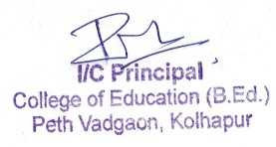

**Student Name list**

**B.Ed-2022-23**

**B.Ed-I**

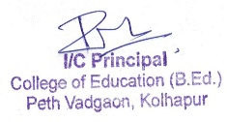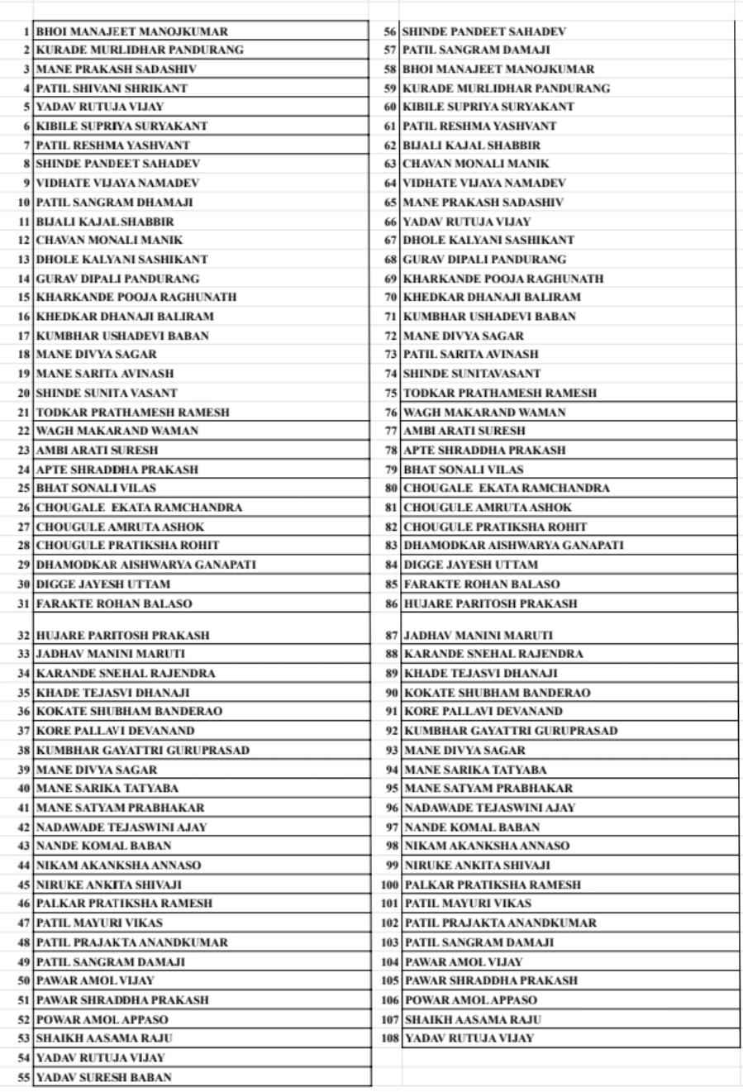

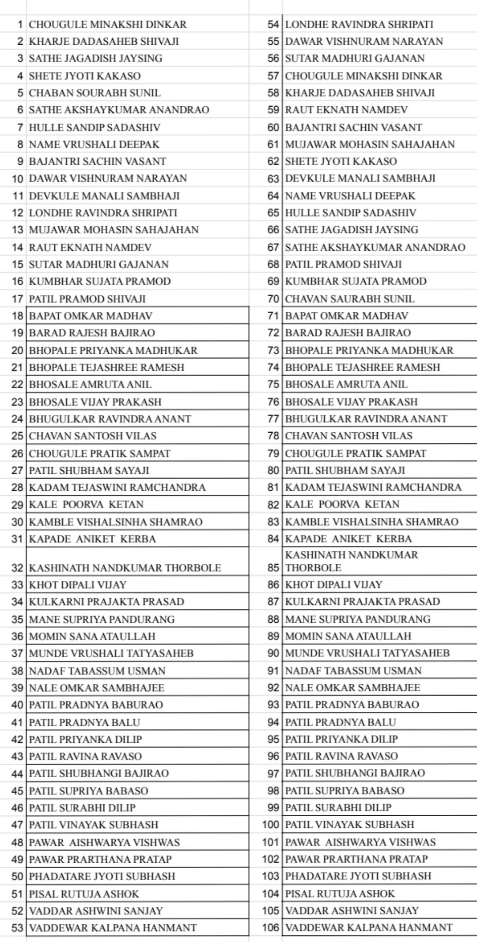**B.Ed-II**

