5 Easy Steps to search catalogue/OPAC

5 EASY STEPS FOR OPAC

Step 2

Type here only one of the following

1. Author’s name OR

2. Title OR

3. Subject

Step 3

Three options are given here. You select Phrase search option

Step 1

Select language

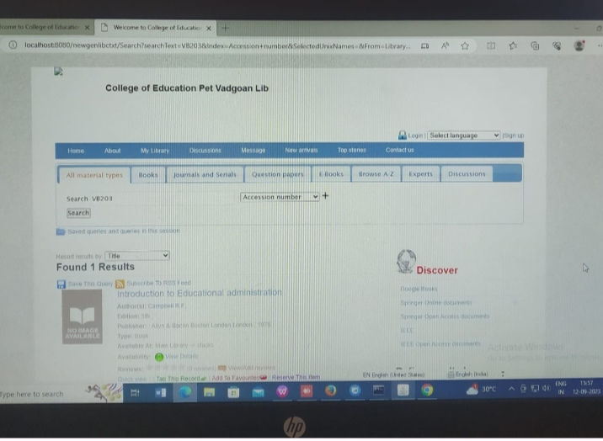

Step 5

Click on Search Button

4 Select one appropriate field from here:

1.If you typed author’s name in step 1, then select author field

2. If you typed title in step 1, then select title field

3. If you typed subject in step 1, then select subject field