3.3.4

* Addressing Societal Issues: Outreach programs can address specific societal issues, such as literacy rates, mental health awareness, or environmental education. By educating the community on these matters, B.Ed programs contribute to positive societal change.
* Social Inclusion:Outreach programs can promote social inclusion by providing equal educational opportunities to marginalized groups, reducing disparities in education, and fostering a more inclusive society
* Civic Engagement:By engaging with the community through outreach programs, B.Ed students and educators can also instill a sense of civic responsibility and active citizenship among participants, creating a more engaged and responsible society.

These types of programs can reduce the educational disparity in the society and increase the participation of the society as well as a process of bringing about multifaceted positive change in the society by enhancing the teaching skills.

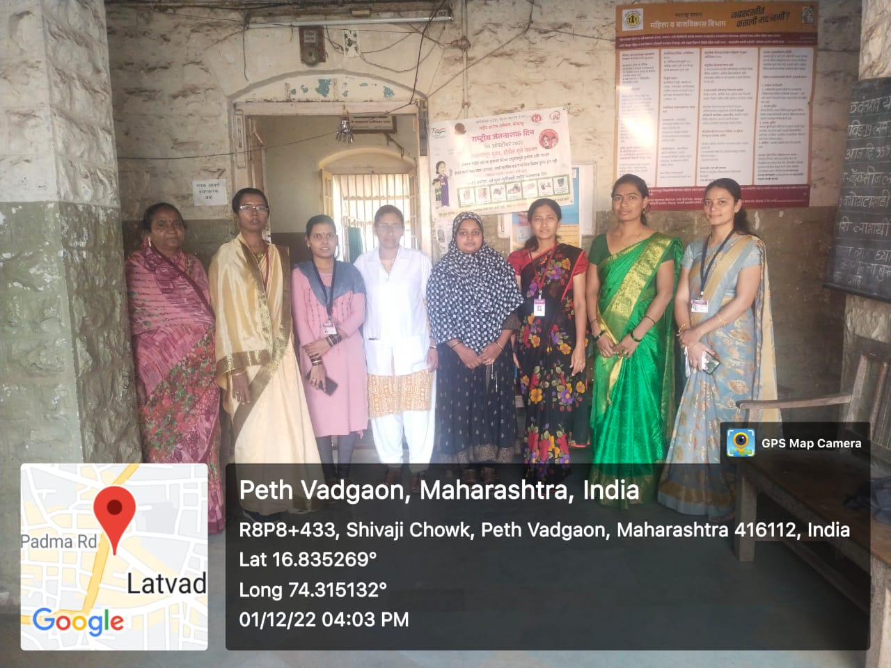**Visit to Primary Health Center on World AIDS Day**

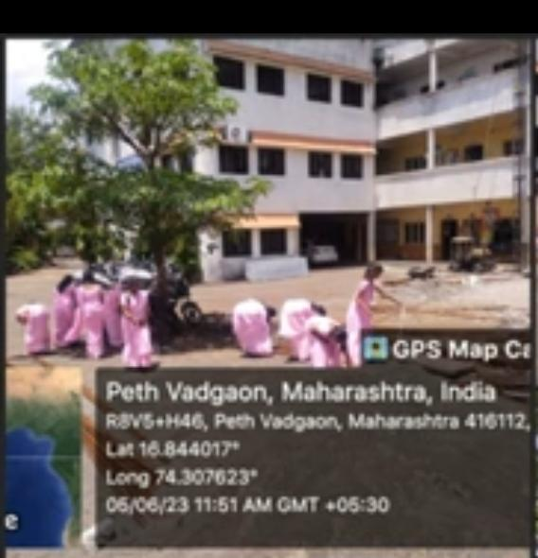

**Plastic free campaign**

