**Approval letter**

The organization provides financial assistance to teachers and students for workshops and seminars. In future we will organize various workshops for our staff which will guide them for their professional development and also various seminars for the student teachers of our college.

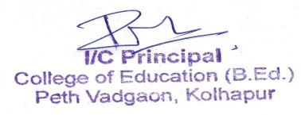

**College of Education B.Ed Peth Vadgaon**

**Institution policy of employee -**

The specific policies regarding employees at a B.Ed college can vary depending on the institution and its governing body. However, typical policies for employees in a B.Ed college may include:

* Employment Contracts: Details regarding the terms and conditions of employment, including job roles, responsibilities, salary, benefits, and duration of employment.
* Code of Conduct: Expectations for professional behavior, ethics, and standards of conduct for faculty and staff.
* Academic Policies: Guidelines for curriculum development, teaching methods, assessment, and academic integrity.
* Attendance and Leave: Rules regarding attendance, punctuality, and procedures for requesting and granting leave.
* Grievance Procedures: Processes for employees to address and resolve workplace concerns or disputes.
* Professional Development: Opportunities for faculty and staff to enhance their skills and knowledge through training, workshops, or conferences.
* Compensation and Benefits: Information on salary scales, bonuses, health insurance, retirement plans, and other employee benefits.
* Safety and Security: Policies related to workplace safety, security, and emergency procedures.
* Discrimination and Harassment: Anti-discrimination and anti-harassment policies to ensure a safe and inclusive work environment.
* Termination and Resignation: Procedures for ending employment contracts, including notice periods and exit interviews.

